Table of Contents

CHAPTER I 3

Overview of the technology 3

Objectives 5

Scope and Limitations 5

Significance of the Study 7

CHAPTER II 8

Mobile Games 8

Gaming in Education 8

Android Platform 10

Programming Language (C# and Mono Tool and Unity) 12

Blender 13

RPG Maker MV 13

Game Genre 13

REVIEW OF RELATED SYSTEMS 15

**Galaxy Shooter: Space Invader** 15

**Rome: Total War** 16

**The Respawnables** 17

**Criminal Case** 17

**SUMMARY OF RRS** 18

CHAPTER III 19

Unity Game System Requirements 19

Game Logic/Game Flow 19

Story 22

Mechanics 22

Winning Condition 34

Losing Condition 35

Process Flow 36

Functions and Features 36

Story Board 43

Actual Screenshot 59

CHAPTER IV 75

CHAPTER V 78

CHAPTER VI 80

REFERENCES 81

APPENDICES: 85

Appendix A: Historical Facts of the Philippines 86

Appendix B: Questions for assessment 90

Appendix C: User Requirements 98

Appendix D: User Acceptance Test 101

Appendix E: Test Plan 112

Appendix F: Test Cases 120

Appendix G: Acceptance Letter 148

# **CHAPTER I**

**Introduction**

## Overview of the technology

Games existed since ancient times; they have been a part of every culture such as sports which relies on physical fitness while other games feature mental and psychological stimulations. Games are activities where players participate for enjoyment, learning, or communications. Games can give the mentioned benefits not only for children but also for adults. Children’s mental capabilities can be stimulated or improved using educational games. [15]

Today many people use smartphones because it can do many things and can be bought easily. With the use of smartphones, a person can do multiple tasks performed by multiple devices with the use of a single device, especially when connected to the internet. A user can communicate with other users in many ways, find anyone or anyplace on the globe, and record moments with the use of video, sound, or pictures. [26] Smartphones are cheap and can reach as low as Php 6,000 in retailers of Samsung and Asus also in the first quarter of 2016 about 3.5 million smartphones were shipped in the Philippines. [27]

Smartphones use mobile applications, commonly known as an app, which provides services similar to those who have access to personal computers. Mobile applications run on popular smartphone platforms like Blackberry, Windows Phone, Android and iOS, mobile applications can be easily downloaded by the given application distribution platform with their corresponding smartphone platform. There are different categories of mobile application like Utilities, news, entertainment, social networking, and, the most popular, game. [29]

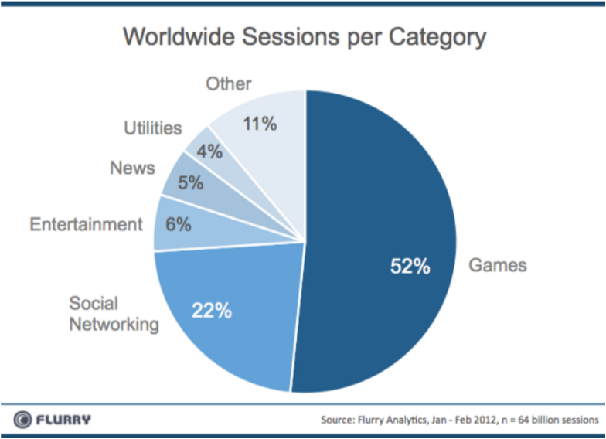

**Figure 1.1 Mobile game as the most popular category [29]**

Mobile games are popular because they can give user nostalgic feelings, can be cheap as free, and can portray life/real time. [1]

The power of games can be higher than just entertaining users or passing time. Gaming in education can improve practical skills, can expose to rarely used skills, and can develop expertise. Students playing educational game can teach them practical skills like building or mixing chemicals without risking damage to equipment. Students also can simulate rare occasion that are hard to experience because of many reasons but using games to simulate as general in time of war, they can experience being that general. Students can copy the training and learn like experts because the former can “walk in the shoes” of the latter, also, experts can further train their knowledge and skill set by simulation of new situations. [3]

Youth today lacks knowledge about the great contribution of General Antonio Luna, a hero during the Philippine-American war, who defended our homeland, the Philippines. This study aims to spread General Antonio Luna’s greatness as a military general during the war. According to Kallie Szczepanski, an Asian history expert, Aguinaldo’s “most able general” and according to General James F. Bell, an American general who faced General Antonio Luna, “was the only general the Filipino army had”. General Antonio Luna’s death can be considered as the beginning of the fall of Philippines to American hands. [30]

## Objectives

Our main objective is to develop **General Luna: The Game** mobile game.

Specifically,

1. Develop a mobile game that is based on the historical life of General Luna;
2. Develop a mobile game composed of four camps representing levels of difficulty.

## Scope and Limitations

The game will run in Android OS devices. The game will focus on General Antonio Luna when he became the *Heneral ng Hukbong Sandatahang Lakas ng Pilipinas*. It will be a single player adventure game. The game will have 4 camps representing the levels in the game. Each camp will have a different game. The target users for this game is elementary to high school students. The levels of the game will depend on what game they will encounter to avoid repetition [31]. Before the games begin, the player is required to answer 50 questions; these questions will be counter check in the post-game quiz so the player and the person to assess the player’s progress. The player will play through 4 different games; specifically, object finding game, top-down shooting game, maze game, and survival game.

    The object finding game is a game where the player will have to search for objects or items. These objects or items either tells a story about general Antonio Luna or is significant to his life, also, these objects or items will be seen from the player’s point of view. The player may be required to interact with a place or other objects to search for the object or item. The object finding game will have a total of 3 stages; as the stage increase, more items will be required to be found by the player in a shorter time, furthermore, finding some objects or items will be seen in the players perspective increase in difficulty.

    The top-down shooting game is a game where the player will act a general Antonio Luna as the latter charges towards American enemy lines. The player will be given 5 lives. The player will also encounter bosses to fight and the last boss is general McArthur. The player will be positioned at the bottom of the screen, on the other hand, the enemies will be positioned at the top of the screen. The top-down shooting game will have a total of 4 stages; as the stage increase, harder and more powerful enemies will be encountered by General Antonio Luna.

    The maze game is a game where the player will reenact General Antonio Luna’s travel from his base camp stationed on a mountain towards Kawit, Cavite, where the general is ordered to go. The player will have to walk through mazes. Each maze is designed with different scenery to act as if General Antonio Luna is going through various places. The maze will also have enemies for the general to fight against, also, as an option, the general may rescue Filipino prisoner. The maze game will have 4 stages with different scenery; as the stage increase, the player will have to walk through more complex and bigger mazes, in addition, the enemies inside the mazes are harder and more powerful.

    The last game is the survival game, in this game the player act as General Antonio Luna as he fights for his life against the treacherous assailants who betray General Antonio Luna. The game will start by reenacting how the assassination of the general is settled. The game start when the first blow by the assailants is thrown.  The player can equip either a sword or a pistol to fight against his’ assailants. On the other hand, the assailants can hold either a sword or a rifle. The survival game has only one level; as time progresses, the spawn assailants of General Antonio Luna will be more difficult to fight. The survival game will only end when General Antonio Luna is killed.

## Significance of the Study

Using games as a way of teaching have many benefits to teachers and students; for teachers as an alternative for delivering lessons and for students, while, for students increase focus on the subject, increase decision making of students, and increase collaborations.

A teacher can offer games to students for them to be more active in class and develop critical thinking skills. Teachers also have the choice to deliver lessons to students which are portable, so teachers can easily deliver the lesson and socialize with students and the involvement of game as a way of teaching can contribute to their style as new and updated way of teaching. [10]

Students are having fun playing games; students focus on game thus they can absorb more information on the subject presented by the game. Students will encounter parts in the game where they will fail continuously but with failure, players will try again until they make decisions correctly and complete or overcome that part. [3] Students playing the game will have experience which they can share with each other and even collaborate to one another about the game’s subject and walkthroughs. [10]

# **CHAPTER II**

**REVIEW OF RELATED LITERATURE**

## Mobile Games

Games that are designed for mobile devices are called mobile games. Mobile gaming became popular because of portability, console quality titles, cheap and free games and of course they are fun to play with. Mobile games are easily accessible. Practically everyone has a smart phone nowadays. You can easily download any game and start playing right away. Some games that appeared on other consoles first can be played in your mobile devices giving gamers the nostalgic feeling when playing the games, they have played for a long time ago. A lot of games that are free-to-play are available on the App store and Google play. You don’t have to spend real money to play fun and exciting games. [1]

Mobile games also ranged from simple games to refined ones. It is like playing 2D games which is snakes from our nokia phones to playing 3D games like Pokémon Go which is portraying real time game. As these games evolve during time smart phones also have a large range of connectivity features it can be through infrared, Bluetooth, WI-FI, and 3G. [2]

## Gaming in Education

Given these kinds of video games, is it compatible for learning and gaming be a process of outcomes in education? Boosts in subjective and learning science have recognized components of ideal learning situations. Also, game developers have different approach in tackling and implementing features of these gameplays:

Clear learning goals: When having a good game of course gaming goals are clear, and you will know the game process and apply what you have learned in real life situations.

Broad experiences and practice opportunities that continue to challenge the learner and reinforce expertise: In gaming industry, students are presented with a wide set of understandings and training prospects. You can also work well in making gears and equipment more realistic or fly through inside a cell. Learning from a domain of color, difficulty, and challenges that learners as opposed to an arrangement of theoretical certainties without genuine context. The main lesson of this is that you should always practice repeatedly to gain mastery of the said game.

Continuous monitoring of progress and use of this information to diagnose performance and adjust instruction to learner level of mastery: Good games continually display progress by using updates and getting feedback from the user of the said game. A good game moves at a high rate where it tests how the learner or student approach the objective of the game and testing his/her abilities. Going to a higher stage challenges students to think more and master each phase of it.

Encouragement of inquiry and questions, and response with answers that are appropriate to the learner and context: Interesting games inspires students to get information and game strategies concepts for their research and get it from the internet, studies, friends, web sites and many more. These learning environments can be too expensive in today’s classroom condition. These technologies make the game and learning environment to be more affordable in a way that it can be easily played through a device.

Time on accomplishing a task: This is the process where gamers tend to repeat the same task all over again because they want to master the game and they are urged to always give their best during playing. Game designers prevented these kinds of things to happen because they want learners to be engaged with the game to avoid boredom and always keep their attention to their specific objective.

Motivation and Strong Goal Orientation: Motivation is a big part in a life of a gamer because there will be parts where you will fail and fail all over again, but the thought of pursuing one objective makes them realize that failing is important in their lives because it improves them in their decision making. This is a quality which that could contribute to their learning and teaching process. [3]

According to (Ron Tarr, 2011) “The bottom line is: Games in education, I think, would be wonderful if we really had a good handle on what our objectives are, and we were prepared to standardize curriculum,” It says that focusing on objectives is a key factor when it comes to making mobile games. Preparing such would be a fit to the curriculum for students. [4]

Teachers tend to offer games for students in order to make learning a way of fun to students it contributes to their teaching style and improve students develop their skills and also be able to socialize with their fellow classmates. They also make History as their selected digital game to make their topic more interesting and these games are being used to improve collaboration and their way of thinking and solving the problem. [10]

## Android Platform

Android is an operating system for mobile devices developed by Google. It is used mostly for touchscreen mobile devices, such as smartphones and tablets. Android was first developed by Android, Inc., and was later acquired by Google in 2005. The first Android-powered device reached the market in 2008. [5] Android powers hundreds of millions of mobile devices in more than 190 countries worldwide. It is the largest installed base of any mobile platform. [6]

The Android platform contains an Linux-based operating system, a GUI, a Web browser and applications that can be downloaded in the app store like Google Play Store. Android runs on both of the most widely deployed cellular standards, GSM/HSDPA and CDMA/EV-DO. Android also supports Bluetooth, EDGE, 3G communication protocols, Wi-Fi, SMS Messaging, MMS, video/still digital cameras, touchscreens, GPS, compasses, accelerometers and accelerated 3D graphics. [7]

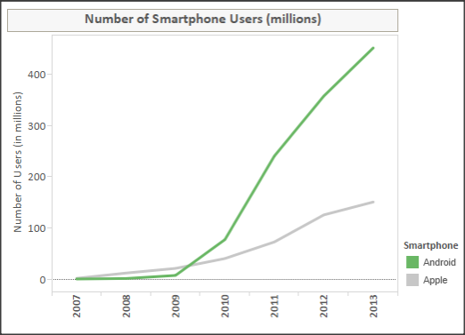

**Figure 2.1, “Growth rate of Android Users from 2007 to 2013”**[8]

Android’s openness has made it a favourite for consumers and developers alike, driving strong growth in app consumption. More than 1.5 billion apps and games is being downloaded by Android users from Google Play Store every month. It provides everything developers need to build best app experiences. Android also let developers deploy their apps broadly to hundreds of millions of users worldwide through the app store.Google Play Store is the leading marketplace for selling and distributing Android apps. Developers can control how they sell their apps in Google Play. [9]

## Programming Language (C# and Mono Tool and Unity)

C# is a programming language which is type-safe object-oriented language used for developing secure and robust applications running on .NET Framework. C# can be used to create XML Web service, Windows client applications, database applications and many more. [11] The advantages of using C# programming language for development are of the following:

1. Tools – C# provides an immense number of toolsets and frameworks that supports the language, also, C# programming language development offers a rich and powerful environment.
2. Popularity – Increase in popularity in a programming language results to increase in support and community for the programming language.
3. Flexibility – Flexibility is one of C#’s benefit compared with others. C# is applicable in many areas like REST, APIS, games, mobile applications, and can produce Android and iOS applications with the help of using Mono Tool or Xamarin framework. C# developers have a very cohesive Microsoft-supported set of tools to develop any type of application.

Unity can be used to help in creating 2D or 3D games, also a multiplatform game engine that allows developers to target more devices easily. Asset Store gives developers a way to get ready-made either free or purchasable assets, extensions, plug-ins, environments and models. [13]

## Blender

Blender is an open source and free suite made for 3D creations. Blender supports necessities needed for 3D making like modelling, rigging, animation, simulation, rendering, compositing and motion tracking, even video editing and game creation. Blender is well suited for small and big scales of projects that can interact with different engines. A community-driven project under the GNU General Public License (GPL), helps the public to be empowered leading to new features, repulsive bug fixes, and better usability. [14]

## RPG Maker MV

RPG Maker MV was released on October 23, 2015 and published by RPG Maker was created to fulfil the desire of creating an original RPG without programming knowledge. RPG Maker MV can create RPGs for PCs and smartphones. It uses the well-known JavaScript, in combination with HTML5. Using JavaScript, you will be able to transform the game to your liking. You will have the ability to control all parts of the game. RPG supports multiple platforms. Using the plugin manager, you can add a JavaScript file you created to modify the game. Users will be able to build games for Windows, Mac OSX, Android, iOS and Web Browsers (with HTML5 support). It also has a built-in database that stores all the items you needed in the game. [25]

## Game Genre

There are many types of games that you can tackle in your life it may include action, adventure, fighting, strategy games, and lastly educational games. Action games are more on the physical battle and its response to attack motion and it is how players react to opponents and their fast-paced reaction through battle. Adventure games have most of the exploration sides and it’s either finding something or mazes to be solved before coming up to the right answer. Discovering new knowledge about the game can also be helpful through adventure. Fighting games also depend on how the opponent will react to whatever move he will do and it is more on a two-player game which improves social interaction with others. Strategy games involves camps, people, towers, collection of gold and etc. these kinds of games help you manage them and helps you to win a specific game and it is categorized in either real-time strategy (RTS) and also turn-based strategy.

The proposed mobile game is about educational game which involves also adventure type of game which will connect to the life of General Luna as our main character.

Educational games give learning to the users about a specific subject or history and uses game as the medium of learning. Educators as well as students can use this also as a sign of collaboration in which they can interact with each other and by interaction they can have learning in a more exciting way. In addition, educational gaming can help students in developing their hand-eye coordination. [24]

One popular game nowadays that involves with history is “Assassin’s Creed”. During the Third Crusade (1189-1192), history records indicate there was a guild of assassins based at the castle of Masyaf, where they had been active for many years. When arriving cities, Altair the main character must locate an assassin’s bureau which he will be further discussed by the local rafiq. And by this, he gains basic knowledge of whom his target will be and as he goes along and continue to understand his objective then he will do the assassination. After this he will be rewarded new weapons and he will continue to his next task.

## REVIEW OF RELATED SYSTEMS

### **Galaxy Shooter: Space Invader**

Galaxy Space Invader is a space themed survival shooting game. To accomplish the tasks, you must have the courage and wisdom. In this bullet hell shooter game, you will be faced with an increasingly considerable number of projectiles and enemies. As the game progresses, you will earn the right to upgrade your spacecraft to bring it to full lethal capacity. Your goal will be quite challenging as you will have to save the Universe from its evil enemies.

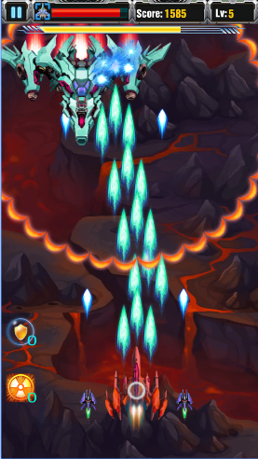

**Figure 2.2** [18]

### **Rome: Total War**

Rome: Total War is the third game of the Total War series developed by Creative Assembly. It is a strategy game in which the player fights historical battles that happened during late Roman Republic and early Roman Empire from 270BC - AD 14. [19] There are two types of gameplay in RTW, first is the campaign mode where you expand your empire by conquering cities and provinces, make improvements and moving your armies around the map. The second gameplay is the real-time battles in which you use tricks and techniques to defeat your enemy in combat. [20]

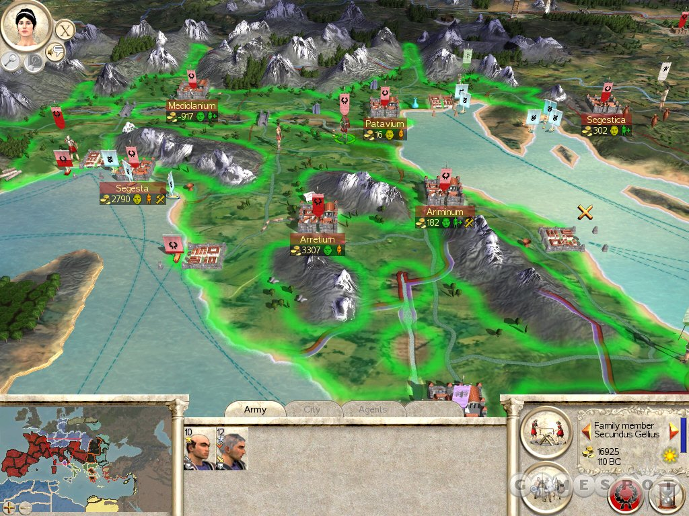

**Figure 2.3** [20]

### **The Respawnables**

Respawnables is an exciting, third person shooter game, packed with a large variety of [weapons](http://respawnables.wikia.com/wiki/Weapons), [gadgets](http://respawnables.wikia.com/wiki/Gadgets), accessories and other fun tidbits to fuel your blood-lust as you go on a journey to dominate all that is in your way!

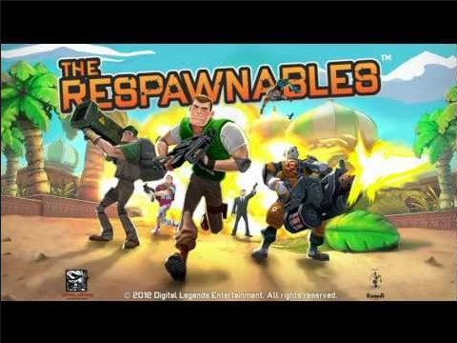

**Figure 2.4** [22]

### **Criminal Case**

Criminal case is a game that lets you find hidden objects in an investigation process that can be a mystery, crime and etc. You act here as an investigator to what is needed in the specific game and in order to investigate you are given clues to what should be found and players earn stars for finishing the game or completing the mission, They also interview suspects of the crime, and piece together gathered information to solve the mystery or case. [23]

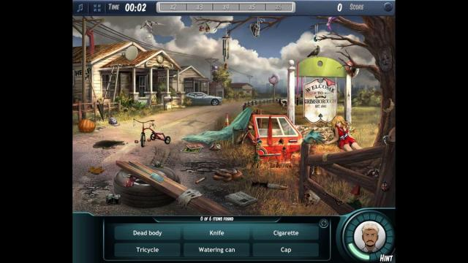

**Figure 2.4** [23]

### **SUMMARY OF RRS**

The researchers found four games which could be related to the proposed project named: Rome: Total War, Civilization Revolution, and Criminal Case. The researchers discussed the unique features and provide a brief description of the games. All the related systems are based on historical facts thus players can learn something about the history while enjoying the game and lastly Criminal Case talks about adventure which is our genre.

# **CHAPTER III**

**Conceptual Framework**

This chapter discusses the logic of the proposed game. Further, it describes how the proposed game works through story board. These concepts are discussed below.

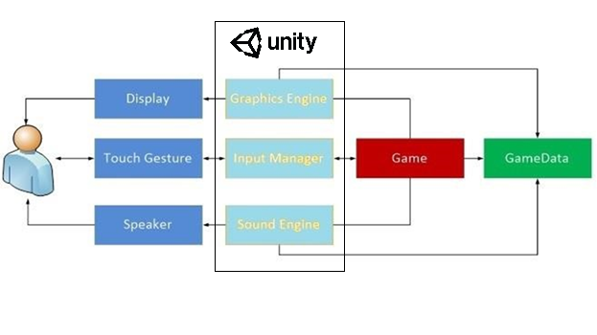

**Figure 3.1 Conceptual Framework**

## Unity Game System Requirements

* Android: OS 4.1 or later; ARMv7(cortex) CPU with NEON support or Atom CPU; OpenGL ES 2.0 or later.

## Game Logic/Game Flow

The game logic describes the flow of the game. It indicates the steps and basic rules of the game.

1. As the user run the application. First, the splash screen will appear to ask login authentication.
2. After the game was loaded, the main menu screen will appear whether to start or exit the game.
3. Start Game: if chosen, the game will proceed to the next scene
4. Continue Game: if chosen, the game will proceed to the scene where he stopped.
5. Exit: if chosen, the game will automatically close.
6. If the player selects play game, the game will proceed to pre-assessment scene then proceed to the next scene after completing the quiz.
7. When the pre-assessment is completed, the player can open the option menu by pressing the cog button located at the upper right screen. Option menu includes: Resume, Restart, and Quit.
8. As the player goes directly to the map where he will select one of the camps in order to play the game.
9. As the player goes to one of the camps there will be a specified game where he will find things that is needed.
10. This game will be timed every level; which is 30, 60, 90 seconds.
11. Every item that they find will correspond by using the button to trigger the item.
12. As they finish the task the text will fade as they find the item.
13. Every item’s location will be randomized every stage.
14. To finish the game, the player should find the exit point going to the next stage.
15. After that they will continue the finding of things and then the journey to that camp will end.
16. After they accomplished the said task they will go on through the next camp which is top-down shooting game where General Luna will shoot the American soldiers and every stage will have its boss stage.
17. There will be 4 different bosses that Luna will encounter. It will be General Frederick Funston, Irving Hale, Lloyd Wheaton, and Arthur McArthur.
18. There will be a random dropdown power up for every stage so that it will help Luna’s firing range goes faster.
19. Once completed they will proceed to the next camp
20. Next is a game where there will be obstacles that they will face in order to fully understand the story in a form of maze.
21. There will be interactions with different soldiers and they will give you information about the quiz and the soldiers will disappear after it has found.
22. This game will be time based and as the level goes higher the map will enlarge and the time will increase also. The time per level will be 60, 80, 120, 150 seconds.
23. After searching the soldiers, the player should find the exit path leading to the next stage or level.
24. After this the player will proceed to the next game.
25. The last camp is the last game where General Luna will face a survival game.
26. There will be a cut scene where Luna will go to Cavite that he has received a telegram from the president in which he saw Padre Paterno and he will be assassinated by Filipino soldiers.
27. Luna will battle Filipino soldiers that has sword and gun.
28. This game will be time based and as the time progresses the number of Filipino soldiers will increase.
29. There will be power ups available during the survival which Luna can pick up to increase his health.
30. To win in this game, the player should have 200 kills or higher to finish the game.
31. After the survival game there will be a post assessment for the player.
32. End Game

## Story

The story is about the life of General Antonio Luna. It started when Antonio Luna was proclaimed the *Heneral ng Hukbong Sandatahang Lakas ng Pilipinas*. He led his troops during the Philippine-American War and faced great odds both from the American and his own countrymen.

The first battle he fought was against the American troops led by General McArthur Jr. Luna then recruit 4,000 soldiers by declaring his infamous *Artikulo Uno* which states that, all who refuse to follow his order shall be executed without the benefit of a trial in a military court. After the recruitment, Luna assigned a task for Lieutenant Garcia to scare the American army while they are having their feast.

When General Mascardo refused to deploy reinforcement, General Luna left Bagbag to confront General Mascardo in Pampanga. While that was happening, General Gregorio del Pilar was being attacked by the American army in Bagbag.

## Mechanics

**Finding Game**

(Level 1) The main objective is to find all these objects: Bolo, Philippine flag, Soldier, *Pluma* and *Agimat*. The player must find all the objects and exit the area within the allotted time (60 seconds). The scoring system will be represented by stars. The stars acquired represent how fast the player finished the game. If the player failed to meet the objective, the player loses and must repeat the stage. The player will get three (3) stars if the time remaining before he finished the game is 25 seconds or higher, two (2) stars if less than 25 seconds and one (1) star if less than 10 seconds. The player must get at least one (1) star in this stage to proceed to the next stage.

**Rules:**

* Objects to find (5)
* exit point (1)
* Starting time (60 seconds)
* 0 star - Did not finish on time

**Scoring System:**

* 1 star – Time remaining before the player finished the game is less than 10 seconds
* 2 stars – Time remaining before the player finished the game is less than 25 seconds
* 3 stars – Time remaining before the player finished the game is 25 seconds of higher

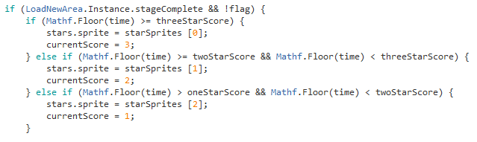

**Figure 3.2 Finding Game Scoring System Code Snippet**

(Level 2) The main objective is to find all these objects: Revolver, Philippine flag, Belgium Flag, Cedula, *Kalesa*, Jeep, KKK Flag. The player must find all the objects and exit the area within the allotted time (90 seconds). The scoring system will be represented by stars. The stars acquired represent how fast the player finished the game. If the player failed to meet the objective, the player loses and must repeat the stage. The player will get three (3) stars if the time remaining before he finished the game is 40 seconds or higher, two (2) stars if less than 40 seconds and one (1) star if less than 20 seconds. The player must get at least one (1) star in this stage to proceed to the next stage.

**Rules:**

* Objects to find (7)
* exit point (1)
* Starting time (90 seconds)
* 0 star - Did not finish on time

**Scoring System:**

* 1 star – Time remaining before the player finished the game is less than 20 seconds
* 2 stars – Time remaining before the player finished the game is less than 40 seconds
* 3 stars – Time remaining before the player finished the game is 40 seconds of higher

(Level 3) The main objective is to find all these objects: Bag of coins, Universidad de Barcelona, Universidad Central de Madrid, Jose Rizal, Emilio Aguinaldo, General Funston, Guitar, Sto. Thomas University, General Wheaton. The player must find all the objects and exit the area within the allotted time (120 seconds). The scoring system will be represented by stars. The stars acquired represent how fast the player finished the game. If the player failed to meet the objective, the player loses and must repeat the stage. The player will get three (3) stars if the time remaining before he finished the game is 30 seconds or higher, two (2) stars if less than 30 seconds and one (1) star if less than 15 seconds. The player must get at least one (1) star in this stage to proceed to the next stage.

**Rules:**

* Objects to find (10)
* exit point (1)
* Starting time (120 seconds)
* 0 star - Did not finish on time

**Scoring System:**

* 1 star – Time remaining before the player finished the game is less than 15 seconds
* 2 stars – Time remaining before the player finished the game is less than 30 seconds
* 3 stars – Time remaining before the player finished the game is 30 seconds of higher

**Top-Down Shooting**

(Level 1) The goal of this game is to defeat all American soldiers within the allotted time (60 seconds). Luna will encounter General Frederick Funston as the boss. The player will encounter a total of 17 American soldiers, including the boss. Luna’s gun upgrades every stage, but it will not have any upgrade yet in this stage since it is the first stage. The stage will be cleared after the player defeated all the enemies. When the player defeated an enemy, he will gain certain number of points stated below. The points will be converted to stars and the stars acquired represent how well the player performed throughout the game. The player will receive 3 stars if he got a score of 4700 or higher, 2 stars if the score is less than 4700, and 1 star if the score is less than 4500. The player must get at least one (1) star in this stage to proceed to the next stage.

**Rule:**

* Starting Time (60 seconds)
* General Luna’s health ( x5)



* American Soldier health = 1
* Boss health = 10
* Gen. Luna’s gun (Every hit decreases one (1) in enemy health)

**Scoring System:**

* 0 star = Gen. Luna died, or the player did
* 1 star = (defeated all the enemies & score is less than 4500 points)
* 2 stars = (defeated all the enemies & score is less than 4700 points)
* 3 stars = (defeated all the enemies & score is greater than or equal to 4700)

**Point System:**

* Points per enemy defeated – 100
* Points per boss defeated – 1000
* Points per health remaining – 200
* Points per time (seconds) remaining – 50

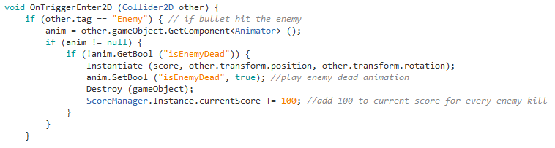

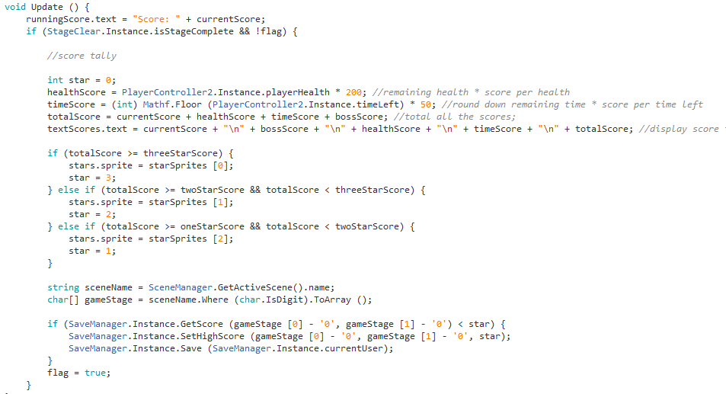

**Figure 3.3 Top-down Shooting Score Code Snippet**

To get the total score the player got after he finished the game, we get the current scorewhich is equal to enemies defeated times 100. Then get the remaining health multiplied it to 200. Get also the boss score which is equal to 1000. Lastly, get the time left, round it down and multiply it by 50. Add all the scores to get the total scores. Then check if the total score reached the required the three-star, two-star or one-star score mark. The minimum score or one-star score is the total of enemies defeated times 100 plus boss score (1000). To get two or three stars, the player must finish the game fast and with high number of health.

(Level 2) The goal of this game is to defeat all American soldiers within the allotted time (90 seconds). Luna will encounter General Frederick Funston as the boss. The player will encounter a total of 33 American soldiers, including the boss. Luna’s gun upgrades every stage. In this stage, the bullets of Luna will double in size, so the player can hit the enemies easily. The stage will be cleared after the player defeated all the enemies. When the player defeated an enemy, he will gain certain number of points stated below. The points will be converted to stars and the stars acquired represent how well the player performed throughout the game. The player will receive 3 stars if he got a score of 6700 or higher, 2 stars if the score is less than 6700, and 1 star if the score is less than 6200. The player must get at least one (1) star in this stage to proceed to the next stage.

**Rule:**

* Starting Time (90 seconds)
* General Luna’s health (hearts x5)
* American Soldier health = 1
* Boss health = 20
* Gen. Luna’s gun (Every hit decreases one (1) in enemy health)

**Scoring System:**

* 0 star = Gen. Luna died, or the player did
* 1 star = (defeated all the enemies & score is less than 6200 points)
* 2 stars = (defeated all the enemies & score is less than 6700 points)
* 3 stars = (defeated all the enemies & score is greater than or equal to 6700)

**Point System:**

* Points per enemy defeated – 100
* Points per boss defeated – 1000
* Points per health remaining – 200
* Points per time (seconds) remaining – 50

(Level 3) The goal of this game is to defeat all American soldiers within the allotted time (60 seconds). Luna will encounter General Frederick Funston as the boss. The player will encounter a total of 47 American soldiers, including the boss. Luna’s gun upgrades every stage. In this stage, the bullet speed will increase. The stage will be cleared after the player defeated all the enemies. When the player defeated an enemy, he will gain certain number of points stated below. The points will be converted to stars and the stars acquired represent how well the player performed throughout the game. The player will receive 3 stars if he got a score of 8500 or higher, 2 stars if the score is less than 8500, and 1 star if the score is less than 8000. The player must get at least one (1) star in this stage to proceed to the next stage.

**Rule:**

* Starting Time (120 seconds)
* General Luna’s health (hearts x5)
* American Soldier health = 1
* Boss health = 30
* Gen. Luna’s gun (Every hit decreases one (1) in enemy health)

**Scoring System:**

* 0 star = Gen. Luna died, or the player did
* 1 star = (defeated all the enemies & score is less than 8000 points)
* 2 stars = (defeated all the enemies & score is less than 8500 points)
* 3 stars = (defeated all the enemies & score is greater than or equal to 8500)

**Point System:**

* Points per enemy defeated – 100
* Points per boss defeated – 1000
* Points per health remaining – 200
* Points per time (seconds) remaining - 50

(Level 4) The goal of this game is to defeat all American soldiers within the allotted time (60 seconds). Luna will encounter General Frederick Funston as the boss. The player will encounter a total of 63 American soldiers, including the boss. Luna’s gun upgrades every stage. In this stage, Gen. Luna will now hold two guns. The stage will be cleared after the player defeated all the enemies. When the player defeated an enemy, he will gain certain number of points stated below. The points will be converted to stars and the stars acquired represent how well the player performed throughout the game. The player will receive 3 stars if he got a score of 8900 or higher, 2 stars if the score is less than 8900, and 1 star if the score is less than 8000. The player must get at least one (1) star in this stage to proceed to the next stage.

**Rule:**

* Starting Time (120 seconds)
* General Luna’s health (hearts x5)
* American Soldier health = 1
* Boss health = 40
* Gen. Luna’s gun (Every hit decreases one (1) in enemy health)

**Scoring System:**

* 0 star = Gen. Luna died, or the player did
* 1 star = (defeated all the enemies & score is less than 8000 points)
* 2 stars = (defeated all the enemies & score is less than 8900 points)
* 3 stars = (defeated all the enemies & score is greater than or equal to 8900)

**Point System:**

* Points per enemy defeated – 100
* Points per boss defeated – 1000
* Points per health remaining – 200
* Points per time (seconds) remaining – 50

**Maze Game:**

(Level 1) The objective on this game is to find all the Filipino soldiers in the maze and exit the maze within the allotted time (60 seconds) for the stage to be cleared. The player loses if he failed to meet the objective. The scoring system will be represented by stars. The player will be awarded with a number of stars depending on how fast he completed the game. The player will get three (3) stars if the time remaining before he finished the game is 20 seconds or higher, two (2) stars if less than 20 seconds and one (1) star if less than 10 seconds. The player must get at least one (1) star in this stage to proceed to the next stage.

**Rules:**

* Persons to find (4)
* Exit point (1)
* Starting time (120 seconds)

**Scoring System:**

* 0 star - Did not finish on time
* 1 star – Time remaining before the player finished the game is less than 5 seconds
* 2 stars – Time remaining before the player finished the game is less than 10 seconds
* 3 stars – Time remaining before the player finished the game is 10 seconds of higher



**Figure 3.4 Maze Game Scoring System Code Snippet**

(Level 2) The objective on this game is to find all the Filipino soldiers in the maze and exit the maze within the allotted time (80 seconds) for the stage to be cleared. The player loses if he failed to meet the objective. The scoring system will be represented by stars. The player will be awarded with a number of stars depending on how fast he completed the game. The player will get three (3) stars if the time remaining before he finished the game is 20 seconds or higher, two (2) stars if less than 20 seconds and one (1) star if less than 10 seconds. The player must get at least one (1) star in this stage to proceed to the next stage.

**Rules:**

* Persons to find (6)
* Exit point (1)
* Starting time (80 seconds)

**Scoring System:**

* 0 star - Did not finish on time
* 1 star – Time remaining before the player finished the game is less than 5 seconds
* 2 stars – Time remaining before the player finished the game is less than 10 seconds
* 3 stars – Time remaining before the player finished the game is 10 seconds of higher

(Level 3) The objective on this game is to find all the Filipino soldiers in the maze and exit the maze within the allotted time (120 seconds) for the stage to be cleared. The player loses if he failed to meet the objective. The scoring system will be represented by stars. The player will be awarded with a number of stars depending on how fast he completed the game. The player will get three (3) stars if the time remaining before he finished the game is 20 seconds or higher, two (2) stars if less than 20 seconds and one (1) star if less than 10 seconds. The player must get at least one (1) star in this stage to proceed to the next stage.

**Rules:**

* Persons to find (7)
* Exit point (1)
* Starting time (120 seconds)

**Scoring System:**

* 0 star - Did not finish on time
* 1 star – Time remaining before the player finished the game is less than 5 seconds
* 2 stars – Time remaining before the player finished the game is less than 10 seconds
* 3 stars – Time remaining before the player finished the game is 10 seconds of higher

(Level 4) The objective on this game is to find all the Filipino soldiers in the maze and exit the maze within the allotted time (150 seconds) for the stage to be cleared. The player loses if he failed to meet the objective. The scoring system will be represented by stars. The player will be awarded with a number of stars depending on how fast he completed the game. The player will get three (3) stars if the time remaining before he finished the game is 20 seconds or higher, two (2) stars if less than 20 seconds and one (1) star if less than 10 seconds. The player must get at least one (1) star in this stage to proceed to the next stage.

**Rules:**

* Persons to find (8)
* Exit point (1)
* Starting time (150 seconds)

**Scoring System:**

* 0 star - Did not finish on time
* 1 star – Time remaining before the player finished the game is less than 5 seconds
* 2 stars – Time remaining before the player finished the game is less than 10 seconds
* 3 stars – Time remaining before the player finished the game is 10 seconds of higher

**Survival Game:** The main objective of this game is to defeat a total of 200 Filipino soldiers. The spawn rate (time interval per soldier spawn) of the soldiers increases over time to increase difficulty. Luna needs 200 kills for the stage to be cleared. The starting spawn interval of Filipino soldiers with swords is 5 seconds and will deplete over time until it reaches 1 second. The starting spawn interval of Filipino soldier with gun is 10 seconds and will deplete over time until it reaches 1 second. The player loses if he was defeated before reaching the objective. The scoring system will be represented by stars. The player will be awarded with a number of stars depending on how fast he completed the game. The player will get three (3) stars if he reached the objective in less than 4 mins and 30 seconds, two (2) stars if 5 minutes or greater and one (1) star if more than 6 minutes.

**Rules:**

* Filipino Soldier Sword (Damage = 3)
* Filipino Soldier Gun (Damage = 5)
* Luna Health (100)
* Power up (Restore Health = 10)
* Luna Gun (1 bullet = 1 kill)
* Kills to win (200)

**Scoring System:**

* 0 star = (Died before reaching the required kills (200))
* 1 star = (Killed 200 soldiers in 6 minutes or higher)
* 2 stars = (Killed 200 soldiers in 5 minutes 30 seconds)
* 3 stars = (Killed 200 soldiers in 4 minutes and 30 seconds or lower)

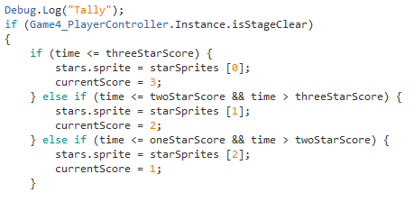

**Figure 3.5 Survival Game Scoring System Code Snippet**

## Winning Condition

The game has 4 camps, every camp will correspond to different types of games specifically: criminal case, top-down shooting game, maze, and lastly, the survival mode. To win these types of game one must accomplish the tasks or objectives for every camp.

**Finding Game:** Find all the items needed and find the exit point during the time to advance in the next level.

**Top-Down Shooting:** Defeat all the American Soldiers within the given time to advance to the next level.

**Maze Game:** Find all the Filipino soldiers in the maze and find the exit level during the time given to advance to the next level.

**Survival Game:** Defeat 200 Filipino soldiers in battle for General Luna to win.

## Losing Condition

The games have time limit and also different types of task that needs to be accomplished if one failed to do the task with the given time he/she will repeat the said camp and will not move on to the next stage or mission.

**Finding Game:** If the player fails to find all the items, the player will repeat the said stage and find the items in different places.

**Top-Down Shooting:** If the player fails to defeat all the enemies in the given time, the player will repeat the stage until he defeats the boss.

**Maze Game:** If the player fails to get all the Filipino soldiers and did not arrive at the exit point on time, the player will repeat the stage.

**Survival Game:** If the player fails to kill 200 enemies during his battle with the Filipino soldiers, the loses and needs to retry the game to accomplish the task.

## Process Flow

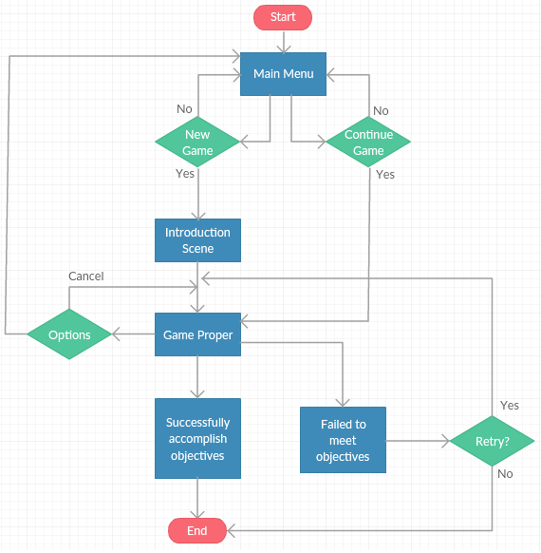

**Figure 3.6 Process Flow**

## Functions and Features

Functions describe the activity or actions of the game while features are distinctive characteristics of the game.

1. Function/s:

* A single player Adventure type game

1. Features:

* Short facts or trivia for every item found
* Time restricted for maze and finding game
* More items to find after each level in finding items game
* Animated NPC’s for maze game

1. Characters and Sprites

|  |  |  |
| --- | --- | --- |
| Name | Thumbnail | Character |
| General Luna | Fighting with Gun |  |
| Apolinario Mabini |  |  |
| Emilio Aguinaldo |  |  |
| General Jose Alejandrino |  |  |
| Gregorio Del Pilar |  |  |
| Pedro Paterno |  |  |
| General Mcarthur | N/A |  |
| General Frederick Funston | N/A |  |
| General Irving Hale | N/A |  |
| General Loyd Wheaton | N/A |  |
| American Soldier | N/A |  |
| Filipino Soldier | N/A |  |

## Story Board

The storyboard will show how the story will flow through pictures.

## Actual Screenshot

The actual screenshot will show how the story will flow.

|  |  |  |
| --- | --- | --- |
| **Picture/Screen Capture** | **Description** | **Category** |
|  | Starting user interface when entering the game. | Pre-game |
|  | Upon login success, the main menu splash screen will appear | Main menu |
|  | For beginning players, pre-assessment be answered for comparison with post game quiz. | Pre-assessment quiz 1 |
|  | Continuation of the pre-assessment quiz | Pre-assessment quiz 2 |
|  | Pre-assessment total score | Pre-assessment score |
|  | After pre-assessment is completed.  First dialogue. Cabinet meeting in Bulacan where members of the elite debate on whether to trust the Americans. | Story to set up the theme of the game |
|  | Continuation of the first dialogue. | Story to set up the theme of the game |
|  | Continuation of the first dialogue. | Story to set up the theme of the game |
|  | Continuation of the first dialogue. | Story to set up the theme of the game |
|  | Continuation of the first dialogue. | Story to set up the theme of the game |
|  | After the first dialogue, A map of four (4) sign board will be shown. Each sign board represent a game. | Overworld for stage choosing |
|  | When the trophy is clicked at the upper right corner of the screen, the player’s quiz scores will be shown | Quiz Scores |
|  | After interaction with the sign board, the player can choose the stage/level of the corresponding game. | Choosing of stage |

|  |  |  |  |
| --- | --- | --- | --- |
| **Picture/Screen Capture** | **Description** | **Item** | **Level** |
|  | Initial view for object finding game. General Antonio Luna starts inside a room. | No item found | Level 1 |
|  | Upon player interaction on a certain location, an object is found.  Object found. | Gulok | Level 1 |
|  | When an item is found, HUD will update according to the corresponding object. | Gulok | Level 1 |
|  | Object found. | Soldier | Level 1 |
|  | HUD update after soldier is found. | Soldier | Level 1 |
|  | When all the items are found, the player should proceed to the exit to clear the stage |  | Level 1 |
|  | Initial view |  | Level 2 |
|  | Object found | Kalesa | Level 2 |
|  | HUD update after soldier is found. | Kalesa | Level 2 |
|  | Object found | KKK Flag | Level 2 |
|  | HUD update after soldier is found. | KKK Flag | Level 2 |
|  | Stage Clear |  | Level 2 |
|  | Object found | Sto. Tomas University | Leve 3 |
|  | HUD update after soldier is found. | Sto. Tomas University | Level 3 |
|  | Stage Clear |  | Level 3 |
| **Picture/Screen Capture** | **Description** | **Enemy** | **Level** |
|  | Once you picked the first stage, the player will first be guided on how to play the game. In this shooting game, the player should tap and hold General Luna and drag him to move | The level has eleven (11) enemy in total including the boss.   * Ten (10) Level 1 soldiers   One (1) Level 1 Boss | Shooting Game Level 1 |
|  | The player will be given three (5) hearts each stage. When the player runs out of hearts, game is over, and he/she must repeat the whole stage.  In this scene, the player managed to kill the first enemy. When an enemy die, he can no longer shoot and the “dead animation” is shown.  Heneral Luna lost a heart when an enemy hit him. When all the hearts are gone, the game is over. | The level has eleven (11) enemy in total including the boss.   * Ten (10) Level 1 soldiers   One (1) Level 1 Boss | Shooting Game Level 1 |
|  | Before the boss stage, a banner saying, “WARNING” will appear. | The level has eleven (11) enemy in total including the boss.   * Ten (10) Level 1 soldiers   One (1) Level 1 Boss | Shooting Game Level 1 |
|  | Stage Clear will appear | The level has eleven (11) enemy in total including the boss.   * Ten (10) Level 1 soldiers   One (1) Level 1 Boss | Shooting Game Level 1 |
|  | Normal Stage | The level has eleven (25) enemy in total including the boss.   * Twenty-four (24) Level 1 soldiers   One (1) Level 2 Boss | Shooting Game Level 2 |
|  | Boss Stage | The level has eleven (25) enemy in total including the boss.   * Twenty-four (24) Level 1 soldiers   One (1) Level 2 Boss | Shooting Game Level 2 |
|  | Stage Clear | The level has eleven (25) enemy in total including the boss.   * Twenty-four (24) Level 1 soldiers   One (1) Level 2 Boss | Shooting Game Level 2 |
|  | Normal Stage | The level has eleven (31) enemy in total including the boss.   * Thirty (30) Level 1 soldiers   One (1) Level 3 Boss | Shooting Game Level 3 |
|  | Boss Stage | The level has eleven (31) enemy in total including the boss.   * Thirty (30) Level 1 soldiers   One (1) Level 3 Boss | Shooting Game Level 3 |
|  | Stage Clear | The level has eleven (31) enemy in total including the boss.   * Thirty (30) Level 1 soldiers   One (1) Level 3 Boss | Shooting Game Level 3 |
|  | Normal Stage | The level has eleven (46) enemy in total including the boss.   * Forty-five (45) Level 1 soldiers   One (1) Level 4 Boss |  |
|  | Boss Stage | The level has eleven (46) enemy in total including the boss.   * Forty-five (45) Level 1 soldiers   One (1) Level 4 Boss |  |
|  | Stage Clear | The level has eleven (46) enemy in total including the boss.   * Forty-five (45) Level 1 soldiers   One (1) Level 4 Boss |  |

|  |  |  |  |
| --- | --- | --- | --- |
| **Picture/Screen Capture** | **Description** | **Interaction** | **Level** |
|  | Stage Selection for maze game | N/A | Main Menu |
|  | Tutorial for first level | N/A | Level 1 |
|  | Interaction with Apolinario Mabini | Apolinario Mabini | Level 1 |
|  | Interaction with messenger | messenger | Level 1 |
|  | Exit and stage clear area | Stage clear | Level 2 |
|  | Start of stage 2 maze | N/A | Level 2 |
|  | Interaction with messenger | messenger | Level 2 |
|  | Interaction with soldier | soldier | Level 2 |
|  | Stage and area cleared | Stage cleared | Level 2 |
|  | Interaction with soldier | soldier | Level 3 |
|  | Interaction with soldier | soldier | Level 3 |
|  | Interaction with soldier | soldier | Level 3 |
|  | Stage and level cleared | Stage cleared | Level 3 |
|  | Starting position for level 4 | Stage level | Level 4 |
|  | Interaction with soldier | soldier | Level 4 |
|  | Interaction with soldier | soldier | Level 4 |
|  | Level cleared | Stage clear | Level 4 |

|  |  |  |  |
| --- | --- | --- | --- |
| **Picture/Screen Capture** | **Description** | **Enemy** | **Level** |
|  | Selection for survival | N/A | N/A |
| C:\Users\User\Desktop\survival\2.png | Start of survival game.  Arrival of general Antonio Luna. General Antonio Luna talks to one of Filipino who planned to assassinate the former. | No enemy | Survival level |
| C:\Users\User\Desktop\survival\3.png | Continuation of how general Antonio Luna’s assassination was set. | No enemy | Survival level |
| C:\Users\User\Desktop\survival\4.png | Continuation of how general Antonio Luna’s assassination was set. | No enemy | Survival level |
|  | Continuation of how general Antonio Luna’s assassination was set.  First attack of assailants on general Antonio Luna | No enemy | Survival level |
|  | Death of enemy | Enemy with sword | Survival level |
|  | Enemy spawning | Enemy with sword | Survival level |
|  | General luna shooting a revolver | N/A | Survival level |
|  | Sample of enemy damage | Enemy with sword | Survival level |
|  | Post Quiz selection | N/A | Post Quiz level |
|  | Post-assessment sample | N/A | Post-assessment level |
|  | Post-assessment sample | N/A | Post-assessment level |
|  | Pre and Post assessment scores | N/A | N/A |

# **CHAPTER IV**

**Methodology**

In this chapter, the proponents will discuss the software development model that will be used in developing the project.

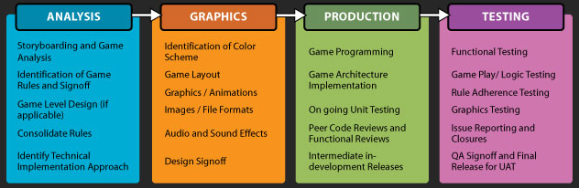

**Figure 4.1** GameZ3 Game Development Methodology

The methodology that the researchers used was developed by GameZ3. GameZ3 is a company that has expertise in developing games on several platforms. This contains the Internet, PCs, mobile phones and other consoles.

The researchers tackled the game play, logic, model used and the story board of the game in the chapter 3 of the project proposal. It discussed how the game is played and how the player can progress in the game. A diagram is used to show the logic of the game and a brief description to discuss the game flow. A storyboard is also provided to portray how the game will be played through pictures.

Project management is one of the most significant things when developing a game application and any other project. During the first phase of the development process, the team analysed and produced the game plan and the logic of the game. It explains how to control the objects in the game and how to make them interact with other objects. Moreover, it explains how the player will perform the possible moves. After creating the game plan and game logic, the game flow is produced to further describe all the options the player can select while playing. It is presented as a flowchart which shows what each option has, giving the whole picture of the game. They also created the winning and losing condition in the game. It explains what must be done to clear a stage or advance to another level and how the player losses. A storyboard is also created using RPG maker to visualize the flow of the game. In creating the storyboard, the researchers first established a timeline which contains the events of the game and identified the key scenes in the story. Then they drew the scenes using the drawing tools and added a brief description what each cell will show. The team has searched some games that they can get ideas from. They found games mentioned in the Review of Related Systems are the best games to base the logic and flow of the proposed game.

In the second phase, the team identified the colour scheme and the game layouts. At this point, the team was able to provide the design of characters, objects, terrains and other things that they used to create the layout of the game. The game graphics and animations were developed using Unity and RPG Maker. The team also used some assets in the Unity Asset Store to aid then in developing the game layout. The store contains free and paid-for models, scripts, materials, audio files, animations and more.

In the production phase, is the phase where the team started to write codes. A review of functionalities was also done to determine if there are additional changes for the enhancement of the game. The team used C# and Unity in developing the game allowing the team to create a 2D game using modern technology. This might be the hardest part of the project since it involves pure logic and coding. In addition, the team has very limited knowledge about C# programming and developing a game. It is a bit of a challenge for them since it will be their first time using this kind of software tool. Luckily, there are a lot of tutorials that can be seen in the web, the Unity Community where the team can post an article to ask for help whenever the team encounter a problem in developing the game. Code Review was applied also in this phase and must set phase before implementing codes in the project. Useful metrics that includes Inspection rate, Defect rate, and Defect Density. The team needs to have a checklist for every mistake that they have done to disregard repeatedly made faults. Unit testing is a technique used to test different modules to determine the needs and matters to the designer himself. The main objective of this on-going unit testing is for developers to identify and analyse bugs or defects from the code and fix it as soon as possible. It allows to improve the design of the project and gives quality as you build the code.

The last phase is the testing phase where the team made an overall functionality test if there are any bugs and other errors overlooked by the team during unit testing. The team conducted a compatibility test to evaluate the application's compatibility within different devices. In performing the functionality test, the team used the black box technique to test the functionality of the system or software. It covers all the possible scenarios as well as failure paths and boundary cases. Upon the completion of unit testing, the components are to be integrated which gives raise to integration testing. Graphics testing was made as well to test if the user interface behaves as the team expected it to be. After each phase are done, the mobile application is now ready for deployment.

# **CHAPTER V**

**Results and Discussion**

In this chapter, the tests conducted are presented and will be discussed briefly. Three iterations for the tests were conducted for the system. Please refer to appendix for the test cases done.

In the first iteration, a series of failures were found in the game which came from the pre-quiz stage when the depletion of timer did not function and found in the first series of levels of the games did not perform correctly specifically; Top-down shooting game when the player cannot be dragged left to right and it failed to complete its stage, Maze game failed when the press button did not trigger the NPC same goes with the NPC’s of finding game, Lastly with the survival game the enemies failed to approach General Luna and failed to give damage caused the game not to end. The rest of the test cases only had minor issues and were resolved by the team.

The results for the UAT will have 20 correspondents which will tackle the following items in each game which is the finding game, top-down shooting game, maze game, and lastly the survival game.

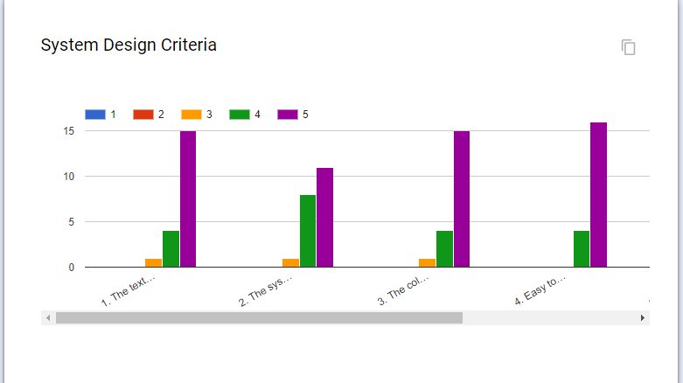

**Figure 5.1** System Design Criteria

In the system design criteria the respondents find it easy to understand and finds the game easy to navigate. The respondents also find the game consistent in terms of visual effects and design.

For the UAT of all the games it is summarized into game functionality, usability, performance, play, effectiveness. Most of the respondents find it easier to play and most of them said that it helped in answering the post quiz which is same as the pre quiz. There are minor comments from the respondents that needs to be addressed to improve the game and for the game to be more user-friendly.

# **CHAPTER VI**

**Recommendation**

The Heneral Luna: The Game is created and developed to support historical education through mobile games. All the result from our tests proves that the game was able to meet all the functional as well as the non-functional requirements. Improvements in game levels and storyline might be added for our user’s satisfaction.

First, Facebook integration would be a great help for users, so they can post scores and let their friends know that they are playing this game and updated in their activities.

Second, since the storyline is limited to the life of General Luna alone the researchers recommend that to not limit the story to just one hero or event since the researchers found that not all users are not into learning history without fun.

Third, the game is only available on Android devices, the researchers can upgrade the application for other mobile platforms; and

Finally, the game to be upgraded in 3D platform and to add more content in it.

# **REFERENCES**

[1] why-mobile-games-are-so-popular

http://www.gamesradar.com/why-mobile-games-are-so-popular/

[2] Definition – What does *Mobile Games* mean?

https://www.techopedia.com/definition/24261/mobile-games

[3] Federation of American Scientists. (2006). *Summit on educational games: Harnessing the power of video games for learning.* Retrieved from http://www.fas.org/programs/ltp/policy_and_publications/summit/Summit%20on%20Educational%20Games.pdf

[4] Ash, K. (2011, March 14). Digital gaming goes academic. *Education Week*, *30* (25), 24–28. Retrieved from http://www.edweek.org/ew/articles/2011/03/17/25gaming.h30.html?tkn=XQDCbAEm%2BOYlXmj8CrgGehhpjbVOReeJEqon

[5] Android Operating System Definition

http://www.investopedia.com/terms/a/android-operating-system.asp

[6] Android tab, mobile app design & development Company | SweBd Vasteras & Stockholm Sweden

http://www.swebd.se/index.php/technology/android

[7] What is Android OS?

http://searchenterpriselinux.techtarget.com/definition/Android

[8] Exponential Business Growth: A Smartphone Case Study

https://systemsandus.com/2014/07/18/exponential-business-growth-a-smartphone-case-study/

[9] Android, the world’s most popular mobile platform

https://developer.android.com/about/index.html

[10] Wastiau, P., Kearney, C., & Van den Berghe, W. (2009). How are digital games used in schools? *European Schoolnet.* Retrieved from http://games.eun.org/upload/gis-synthesis_report_en.pdf

[11] Introduction to the C# Language and the .NET Framework

https://msdn.microsoft.com/en-us/library/z1zx9t92.aspx

[12] REASONS TO LEARN C# By codemaster February 24, 2016

http://www.thesoftwareguild.com/blog/reasons-to-learn-c-sharp/

[13] Unity

https://unity3d.com/unity

[14] Blender : The software

https://www.blender.org/about/

[15] What are games?

https://www.reference.com/hobbies-games/games-5c78b353301607e4#full-answer

[16] The amazing (real) history behind the Assassin’s Creed franchise

http://www.psu.com/feature/20553/The-amazing-(real)-history-behind-the-Assassins-Creed-franchise

[17] Assassin’s Creed

http://assassinscreed.wikia.com/wiki/Assassin's_Creed

[18] Ubisoft – Assassin’s Creed

https://www.ubisoft.com/en-US/game/assassins-creed/

[19] Rome: Total War

http://totalwar.wikia.com/wiki/Rome:_Total_War

[20] Rome: Total War review

http://www.gamespot.com/reviews/rome-total-war-review/1900-6108207/

[21] Sid Meier's Civilization Revolution

http://www.ign.com/games/sid-meiers-civilization-revolution/xbox-360-947005

[22] Sid Meier's Civilization Revolution – GameSpot

http://www.gamespot.com/sid-meiers-civilization-revolution/

[23] Criminal Case

https://www.commonsensemedia.org/game-reviews/criminal-case#

[24] advantages-of-game-based-learning

http://www.brighthubeducation.com/teaching-methods-tips/129304-advantages-of-game-based-learning/

[25] RPG Maker MV

http://www.rpgmakerweb.com/products/programs/rpg-maker-mv

[26] Programming with mobile application

Thomas Duffy, February 6, 2012

[27] Philippines: ‘fastest-growing’ smartphone nation in Southeast Asia

http://www.rappler.com/business/industries/biztech/136777-idc-smartphones-market-philippines-asean

[28] Heneral Luna study guide

http://henerallunathemovie.com/files/Heneral-Luna-Study-Guide.pdf

[29] Mobile-first, indie gaming companies dominate with two-thirds of user sessions on Android, iOS

http://www.adweek.com/socialtimes/mobile-first-gaming-companies-dominate-with-two-thirds-of-user-sessions-on-android-ios/521850\

[30] Antonio Luna, Hero of the Philippine - American War

<http://asianhistory.about.com/od/philippines/fl/Antonio-Luna-Hero-of-the-Philippine-American-War.htm>

[31] Game Development

https://gamedev.stackexchange.com/questions/59132/how-many-levels-should-i-make

# **APPENDICES:**

## Appendix A: Historical Facts of the Philippines

**Philippine Flag**

1. If Philippines is at war, the national flag will be flown upside down with the red band at the top
2. The flag of Cuba influenced the design of the flag of the Philippines as Cuba's revolution against Spain inspired the Philippine Revolution.
3. During the Philippine Revolution, Gen. Emilio Aguinaldo, President of the Revolutionary Government, conceived the flag's design and the first flag was sewn at 535 Morrison Hill Road, Hongkong by Mrs. Marcela Marino Agoncillo - wife of the first Filipino diplomat Felipe Agoncillo, with the help of her daughter Lorenza and Mrs. Delfina Herbosa Natividad, niece of Dr. Jose Rizal and wife of Gen. Salvador Natividad.
4. The Philippine was displayed for the first time in a battle on May 28, 1898 To commemorate that event, May 28 is chosen as Philippines flag day. On June 12, 1898.
5. The eight-rayed golden sun on the Philippines Flag symbolizes unity, freedom, people's democracy, and sovereignty. Each ray represents a province with significant involvement in the 1896 Philippine Revolution against Spain - Manila, Bulacan, Cavite, Pampanga, Tarlac, Laguna, Batangas, and Nueva Ecija, they represent the gigantic steps made by sons of the country.
6. Symbols present in the Philippine flag
   * + Sun - liberty
     + White triangle – Equality that the Filipinos are hoping for.
     + Blue stripe – peace, justice, and truth
     + Red stripe – valor and patriotism
7. The archipelago of the Philippines consist of 7,107 islands.

Reference: Flag of Philippines <http://philippinesflag.facts.co/philippinesflagof/philippinesflag.php>

http://nhcp.gov.ph/the-philippine-flag-symbol-of-our-sovereignty-and-solidarity/

**Agimat/Anting-anting**

1. A special object bestowed with extraordinary powers is kept by warriors, shamans and healers believed to give superhuman powers to overcome hostilities both human and non-human. Our ancestors believed that a special stone, a tattoo, a part of an animal or some mysterious object with the right oracion and rituals will protect from arrows, spears, swords and sickness. Some also believe that these anting-antings can make someone invulnerable and possess unnatural strength and speed, specially on a battlefield.
2. Types of agimat -Agimat na sinusuot, Agimat sa loob, Agimat sa oracion, Agimat sa sulat.

Reference: All About Agimat

<http://www.thepinoywarrior.com/2012/01/all-about-agimat.html>

**Kalesa**

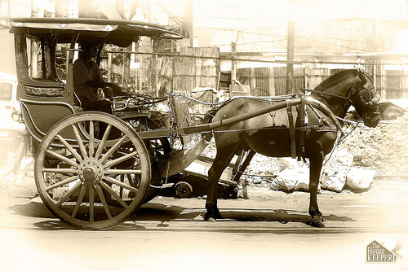

1. The Kalesa also called a “Karitela” is a cart with two large wheels on each side that can accommodate at least four persons. Through the years however the Kalesa’s design, length and passenger capacity has evolved and with more decorative features mainly to attract tourists.
2. For several centuries, the Kalesa is considered as the undisputed “king of the road” until the arrival of the jeepney during the American period. The jeepney - made from the discarded American jeeps – has taken over those routes previously served by the Kalesa. It soon dominated all major thoroughfares relegating the Kalesa into rarity.

Reference: The Philippine Kalesa

<http://hubpages.com/travel/The-Philippine-Kalesa>

**General Luna**

1. Heneral Luna helped establish the first military academy for Filipinos
2. While in Spain, Dr. Jose Rizal and General Antonio Luna almost duel because the latter was drunk and made bad comment towards Nelly Boustead, a woman courted by the two men. The two men exchanged heated words until Luna apologized to Rizal.
3. Upon release from prison in Spain, General Antonio Luna travelled to Belgium, there General Antonio Luna learn the art of war taught by General Gerard Leman
4. When General Antonio Luna travelled to Cavite to meet President Emilio Aguinaldo, the former was assassinated under the hand of Katipunan Soldier. General Antonio Luna received more than 40 bullets and stab wounds
5. General Antonio Luna’s last words during his assassination were “Cowards! Assassins”
6. After General Antonio Luna’s death. The Philippine Army, lead by President Emilio Aguinaldo suffered continuous defeat.
7. The Philippines experienced numerous colonization. First Spain colonization. Second American colonization then Japanese colonization.

Reference: 13 Facts That Prove Antonio Luna Was An All Around Badass

<http://www.filipiknow.net/facts-about-antonio-luna/>

**Katipuneros**

1. Bonifacio’s weapon of choice is the revolve said Yson. “Kaya lang bolo kasi inugnay siya sa kadalasan na gamit ng mga Katipunero.”

Reference: Little-known facts about Andres Bonifacio

http://www.gmanetwork.com/news/story/331595/publicaffairs/katipunan/little-known-facts-about-andres-bonifacio#sthash.YMzjnuYh.dpuf

## Appendix B: Questions for assessment

1. What does the 3 stars in the Philippine flag symbolize?
   1. CALABARZON c. KKK
   2. Luzon, Visayas, and Mindanao d. Courage, bravery, and honor
2. What does the 8 ray of the sun in the Philippine flag symbolize?
   1. Provinces who fought against Spain. c. Phases during the revolution
   2. Heroes of the Philippines. d. Important events in Philipine History
3. When was the Philippine flag first displayed in battle?
   1. May 28, 1989 c. June 21, 1989
   2. May 1, 1989 d. June 1, 1989
4. What country flag gave inspiration for the design of the Philippine flag?
   1. America c. Cuba
   2. Spain d. China
5. What is a special object that either gives power or protect it’s keeper.
   1. Flag c. Agimat
   2. Dagger d. Sto. Nino
6. Which is not considered as an Agimat?
   1. Agimat na sinusuot c. Agimat sa sulat
   2. Agimat sa loob d. Agimat sa dugo
7. What is made from a big bird’s feather?
   1. Pluma c. Agimat
   2. Sword d. Flag
8. Pluma is known to be used by writers and soldiers in battle.
   1. True
   2. False
9. Which is Andres Bonifacio’s weapon of choice?
   1. Revolver c. Spear
   2. Bolo d. Sword
10. Which weapon is usually used by the Katipuneros?
    1. Revolver. c. Spear
    2. Bolo d. Sword
11. KKK stands for Kataastaasang Kagalanggalangang Katipunan ng mga Anak ng Bayan.
    1. True
    2. False
12. Where did Andres Bonifacio founded KKK.
    1. Tondo, Manila c. Pedro Gil, Manila
    2. Taft, Manila d. Malate, Manila
13. When did the “Cry of Pugadlawin” happened?
    1. August 30, 1896 c. August 23, 1896
    2. June 30, 1896 d. June 23, 1896
14. What transpired during the historical event of “Cry of Pugadlawin”
    1. The Katipuneros cry due to hardship
    2. The Katipuneros tear their cedula
    3. The Katipuneros first victorious battle against the Spaniards
    4. The Katipuneros appointed Andres Bonifacio as the supremo
15. The “Cry of Pugadlawin” symbolizes the Katipuneros refusal to be ruled under Spain Tyrants
    1. True
    2. False
16. Which vehicle is popular before the American Period and exclusively owned only by rich family?
    1. Jeep c. Bike
    2. Kalesa d. Tricycle
17. General Antonio Luna is not related to the famous painter Juan Luna.
    1. True b. False
18. General Luna help establish the first _______.
    1. School for Filipinos c. Mansion for Filipinos
    2. Military academy for Filipinos d. Military base for Filipinos.
19. According to General Federick Funston, an American general, who is “the ablest and most aggressive leader of the Filipino Republic”?
    1. General Arthur McArthur c. General Antonio Luna
    2. President Emilio Aguinaldo d. General Gregorio del Pilar
20. Who said that General Antonio Luna “was the only general the Filipino army had”?
    1. President Emilio Aguinaldo c. General Federick Funston
    2. Andres Bonifacio d. General James Franklin Bell
21. When General Hughes said “The Filipinos only had one general, and they killed him”, who was General Hughes talking about?
    1. President Emilio Aguinaldo c. Dr. Jose Rizal
    2. Andres Bonifactio d. General Antonio Luna
22. General Antonio Luna was a scientist?
    1. True b. False
23. In the Philippines, what university did General Antonio Luna studied?
    1. Ateneo University c. De La Salle University
    2. Sto. Thomas University d. University of the Philippines
24. During General Luna’s study in Sto. Thomas University, his scientific paper on what subject won a top prize.
    1. Chemistry c. Military
    2. Physics d. Biology
25. General Luna graduated in the field of ______.
    1. Engineering c. Medical doctor
    2. Mathematics d. Pharmacy
26. In Spain, what university did General Antonio Luna earned his license in pharmacy? a.
    1. Universidad Autònoma de Madrid c. Universidad de Barcelona
    2. Universidad of Navarra d. Universidad Complutense Madrid
27. In Spain, what university did General Antonio Luna earned his doctorate in pharmacy?
    1. Universidad Autònoma de Madrid c. Unversidad Central de Madrid
    2. University of La Laguna d. University of Valladolid
28. General Luna was not a marksman.
    1. True b. False
29. General Luna was a martial artist.
    1. True b. False
30. When did General Antonio Luna started practicing fencing, arnis and shooting gun?
    1. Elementary c. College
    2. Highschool d. Military days.
31. General Antonio Luna was an avid student of military tactics when he was in highscool.
    1. True b. False
32. General Antonio Luna was a legend when using a gun that he can unlit a candle in one shot.
    1. True b. False
33. General Luna’s a master of what type of weapon?
    1. Gun c. Spear
    2. Sword d. Slingshot
34. General Luna trained a group of elite soldiers famously name as ______.
    1. Luna Sharpshooters c. Luna Riflemen
    2. Luna Death Squad d. Luna Marksmen
35. During General Luna’s charge, what saved General Luna from a bullet aimed at his chest?
    1. A medal c. A bag of coins
    2. An agimat d. A booklet
36. Who among the following is not an enemy of General Luna.
    1. General Federick Funston c. President Emilio Aguinaldo
    2. General Arthur MacArthur d. General Irving Hale
37. General Luna was killed by American soldiers.
    1. True b. False
38. General Luna almost had a duel with ______.
    1. Dr. Jose Rizal c. Juan Luna
    2. Andres Bonifacio d. President Emilio Aguinaldo
39. General Antonio Luna and Dr. Jose Rizal almost had a duel because the former disrespected _______.
    1. A military general c. A Jose Rizal’s friend
    2. A woman courted by both men d. A novel Spaniard
40. What country did General Antonio Luna studied the art of war?
    1. Belgium c. America
    2. Spain d. Philippines
41. The archipelago of the Philippines consists of how many islands?
    1. 7,000 c. 7,107
    2. 7,707 d. 7,700
42. What was the aftermath of General Antonio Luna’s assassination?
    1. The Philippine army suffered continuous defeat.
    2. The Philippine army defeated the Americans.
    3. The Philippine army regroup and defended the country successfully
    4. The Philippine army was disciplined
43. General Luna’s last words were “Cowards! Assassins”.
    1. True b. False
44. Who was the American general that luna encountered at the battle in calumpit.
    1. General Arthur Mcarthur c. General Irving Hale
    2. General Franklin Bell d. General John Stotsenburg
45. What country colonized the Philippines after Spain?
    1. Japan c. Cuba
    2. America d. China
46. In the Philippine flag, what symbolizes liberty?
    1. Sun c. Blue stripe
    2. Star d. Red stripe
47. In the Philippine flag, what symbolizes Filipino’s hope for equality
    1. 3 stars and the sun c. Blue stripe
    2. White triangle d. Red stripe
48. The red stripe found in the Philippine flag symbolizes ____.
    1. Valor and patriotism c. Blood sacrificed by the Filipinos
    2. Anger and Hate d. Peace, justice, and truth
49. The blue stripe found in the Philippine flag symbolizes ______.
    1. Valor and patriotism c. Blood sacrificed by the Filipinos
    2. Anger and Hate d. Peace, justice, and truth
50. What is the favorite article of General Antonio Luna when implementing discipline to Filipino soldiers.
    1. Artikulo I c. Artikulo V
    2. Artikulo II d. Artikulo VI

## Appendix C: User Requirements

|  |  |  |
| --- | --- | --- |
| **FUNCTIONAL REQUIREMENT** | | |
| **ID** | **Functionality/Statement** | **Priority** |
| 1 | Login and Log-out | High |
| 2 | Game features for Object Finding Game | High |
| 3 | Game features for Maze Game | High |
| 4 | Game features for Top-Down Shooting Game | High |
| 5 | Game features for Survival Game | High |
| 6 | Save feature | High |
| 7 | Pre-quiz and post quiz for comparison | High |
| 8 | Accurate historical facts | High |
| 9 | Track pad and on-screen buttons for game control | High |
| 10 | Game tutorials | High |

|  |  |  |
| --- | --- | --- |
| **FUNCTIONAL REQUIREMENT – OBJECT FINDING GAME** | | |
| **ID** | **Functionality/Statement** | **Priority** |
| 1 | Item details pop up when it is successfully found | High |
| 2 | The player can move left, right, up and down | High |
| 3 | The items spawn are in a preset location | High |
| 4 | Next stage unlocks when all of the items are found | High |
| 5 | Walls and objects are not walkable | High |
| 6 | HUD is working properly | High |
| 7 | Next game unlocks after completing a game | High |
| 8 | Exit spots are working | High |
| 9 | Buttons are working | High |

|  |  |  |
| --- | --- | --- |
| **FUNCTIONAL REQUIREMENT – TOP-DOWN SHOOTING** | | |
| **ID** | **Functionality/Statement** | **Priority** |
| 1 | The player can move left and right | High |
| 2 | The avatar shoots automatically | High |
| 3 | The enemies spawn at random location | High |
| 4 | Boss stage | High |
| 5 | User can change settings in-game | High |
| 6 | Next stage unlocks after completing a stage | High |
| 7 | Next game unlocks after completing a game | High |

|  |  |  |
| --- | --- | --- |
| **FUNCTIONAL REQUIREMENT – MAZE GAME** | | |
| **ID** | **Functionality/Statement** | **Priority** |
| 1 | The player can move up, right, down, and left | High |
| 2 | NPC’s triggers are working | High |
| 3 | Dialogues are relevant and accurate | High |
| 4 | Exit spots are working | High |
| 5 | Walls and objects are not walkable | High |
| 6 | Buttons are working | High |
| 7 | User can change settings in-game | High |
| 8 | Next stage unlocks after completing a stage | High |
| 9 | Next game unlocks after completing a game | High |

|  |  |  |
| --- | --- | --- |
| **FUNCTIONAL REQUIREMENT – SURVIVAL GAME** | | |
| **ID** | **Functionality/Statement** | **Priority** |
| 1 | The player can move up, right, down, and left | High |
| 2 | Luna shoots by tapping the button | High |
| 3 | Dialogues are relevant and accurate | High |
| 4 | Luna defeats enemies by shooting them | High |
| 5 | Walls and objects are not walkable | High |
| 6 | Luna dies after receiving a fixed number of shots and sword wounds | High |
| 7 | User can change settings in-game | High |
| 8 | Game completes after Luna defeat a specified number of enemies | High |

|  |  |  |
| --- | --- | --- |
| **FUNCTIONAL REQUIREMENT – SURVIVAL GAME** | | |
| **ID** | **Functionality/Statement** | **Priority** |
| 1 | Application Icon | Low |
| 2 | Different Style/Looks for each avatar/group of avatar | Medium |
| 3 | Transitions to another game | Low |
| 4 | Settings(sounds & graphics) | Medium |
| 5 | Reliable loading speed | Medium |
| 6 | Consistency of theme | Medium |

## Appendix D: User Acceptance Test

**USER ACCEPTANCE TEST**

This questionnaire is a part of User Acceptance Test (UAT). As the evaluating user you should fill this questionnaire after testing the program: Heneral Luna:The Game. The following checklist enlists the review process that suffices the test criteria for the requirement and design phases.

* To ensure that the requirements are apt for the game.
* Check for its completeness
* Verify if the goals are achievable and realistic
* Compare with competitor games for compatibility
* Verify if the targets are measurable

|  |  |  |  |  |  |  |
| --- | --- | --- | --- | --- | --- | --- |
| **System Design** | | | | | | |
| Number | Criteria | 1 | 2 | 3 | 4 | 5 |
| 1 | The text is readable and easy to understand. |  |  |  |  |  |
| 2 | The system’s buttons are functioning properly and easy to identify. |  |  |  |  |  |
| 3 | The colors used in the system are pleasing to the eyes and appropriate to the system. |  |  |  |  |  |
| 4 | Easy to navigate. |  |  |  |  |  |
| 5 | Styles and colors are consistent throughout the whole system. |  |  |  |  |  |
| 6 | Allowance of space is provided between buttons and navigation controls. |  |  |  |  |  |

|  |  |  |  |  |
| --- | --- | --- | --- | --- |
| **USER INTERFACE FOR OBJECT FINDING GAME** | | | | |
| Number | Criteria | Yes | No | Comment(s) |
| 1. | **Game Functionality** |  |  |  |
| 1.1 | The game is displayed in a landscape orientation. |  |  |  |
| 1.2 | The items do not move out of the screen/specified area. |  |  |  |
| 1.3 | Font family, typography, size, color and other visual effects used in the game are consistent. |  |  |  |
| 1.4 | Responding to touch events. |  |  |  |
| 1.5 | The items do not perform redundancy |  |  |  |
| 1.6 | Background sound is functioning |  |  |  |
| **2** | **Game Usability** |  |  |  |
| 2.1 | User-friendly Environment |  |  |  |
| 2.2 | Screen design is visually pleasing |  |  |  |
| 2.3 | Game is fun and entertaining |  |  |  |
| 2.4 | Game is easy to play and easy to learn |  |  |  |
| **3** | **Game Performance** |  |  |  |
| 3.1 | There are no delay or lag issues on the game |  |  |  |
| 3.2 | The game is working without crashing |  |  |  |
| **4** | **Game Play** |  |  |  |
| 4.1 | The game entertained and challenged the user |  |  |  |
| 4.2 | Game level is consistent |  |  |  |
| **5** | **Game Effectiveness** |  |  |  |
| 5.1 | The Game has a strong connection to the game’s objective |  |  |  |
| 5.2 | The game was able to help the user to answer the post quiz questions |  |  |  |
| 5.3 | Content of the game is up to date |  |  |  |
| 5.4 | Content of the game is accurate |  |  |  |

|  |  |  |  |  |
| --- | --- | --- | --- | --- |
| **USER INTERFACE FOR TOP-DOWN SHOOTING** | | | | |
| Number | Criteria | Yes | No | Comment(s) |
| 1. | **Game Functionality** |  |  |  |
| 1.1 | The game is displayed in a portrait orientation. |  |  |  |
| 1.2 | The characters do not move out of the screen/specified area and enemies shoot at will. |  |  |  |
| 1.3 | Font family, typography, size, color and other visual effects used in the game are consistent. |  |  |  |
| 1.4 | Responding to touch events. |  |  |  |
| 1.5 | The boss changes in every stage of the game. |  |  |  |
| 1.6 | Spawned soldiers provide redundancy except for the boss. |  |  |  |
| **2** | **Game Usability** |  |  |  |
| 2.1 | User-friendly Environment |  |  |  |
| 2.2 | The sound is in sync with the game. |  |  |  |
| 2.3 | Screen design is visually pleasing |  |  |  |
| 2.4 | Game is fun and entertaining |  |  |  |
| 2.5 | Game is easy to play and easy to learn |  |  |  |
| **3** | **Game Performance** |  |  |  |
| 3.1 | There are no delay or lag issues on the game |  |  |  |
| 3.2 | The game is working without crashing |  |  |  |
| **4** | **Game Play** |  |  |  |
| 4.1 | The game entertained and challenged the user |  |  |  |
| 4.2 | Game level is consistent |  |  |  |
| **5** | **Game Effectiveness** |  |  |  |
| 5.1 | The game has a strong connection to the game’s objective |  |  |  |
| 5.2 | Content of the game is up to date |  |  |  |
| 5.3 | content of the game is accurate |  |  |  |

|  |  |  |  |  |
| --- | --- | --- | --- | --- |
| **USER INTERFACE FOR MAZE GAME** | | | | |
| Number | Criteria | Yes | No | Comment(s) |
| 1. | **Game Functionality** |  |  |  |
| 1.1 | The game is displayed in a landscape orientation. |  |  |  |
| 1.2 | There is time provided for each stage to get out of the maze. |  |  |  |
| 1.3 | Font family, typography, size, color and other visual effects used in the game are consistent. |  |  |  |
| 1.4 | Responding to touch events. |  |  |  |
| 1.5 | Map gets bigger every stage |  |  |  |
| 1.6 | Background sound is functioning |  |  |  |
| **2** | **Game Usability** |  |  |  |
| 2.1 | User-friendly Environment |  |  |  |
| 2.2 | Screen design is visually pleasing |  |  |  |
| 2.3 | Game is fun and entertaining |  |  |  |
| 2.4 | Game is easy to play and easy to learn |  |  |  |
| **3** | **Game Performance** |  |  |  |
| 3.1 | There are no delay or lag issues on the game |  |  |  |
| 3.2 | The game is working without crashing |  |  |  |
| **4** | **Game Play** |  |  |  |
| 4.1 | The game entertained and challenged the user |  |  |  |
| 4.2 | Game level is consistent |  |  |  |
| **5** | **Game Effectiveness** |  |  |  |
| 5.1 | The game has a strong connection to the game’s objective |  |  |  |
| 5.2 | Content of the game is up to date |  |  |  |
| 5.3 | Content of the game is accurate |  |  |  |

|  |  |  |  |  |
| --- | --- | --- | --- | --- |
| **USER INTERFACE FOR SURVIVAL GAME** | | | | |
| Number | Criteria | Yes | No | Comment(s) |
| 1. | **Game Functionality** |  |  |  |
| 1.1 | The game is displayed in a landscape orientation. |  |  |  |
| 1.2 | The characters that general luna will face will spawn until he dies. |  |  |  |
| 1.3 | Font family, typography, size, color and other visual effects used in the game are consistent. |  |  |  |
| 1.4 | Responding to touch events. |  |  |  |
| 1.5 | Background sound is functioning |  |  |  |
| **2** | **Game Usability** |  |  |  |
| 2.1 | The user can switch ON or switch OFF the sound. |  |  |  |
| 2.2 | User-friendly Environment |  |  |  |
| 2.3 | screen design is visually pleasing |  |  |  |
| 2.4 | Game is fun and entertaining |  |  |  |
| 2.5 | Game is easy to play and easy to learn |  |  |  |
| **3** | **Game Performance** |  |  |  |
| 3.1 | There are no delay or lag issues on the game |  |  |  |
| 3.2 | The game is working without crashing |  |  |  |
| **4** | **Game Play** |  |  |  |
| 4.1 | The game entertained and challenged the user |  |  |  |
| 4.2 | Game level is consistent |  |  |  |
| **5** | **Game Effectiveness** |  |  |  |
| 5.1 | The game has a strong connection to the game's objective |  |  |  |
| 5.2 | The game was able to help the user to answer the post quiz questions |  |  |  |
| 5.3 | Content of the game is up to date |  |  |  |
| 5.4 | content of the game is accurate |  |  |  |

|  |  |  |  |  |
| --- | --- | --- | --- | --- |
| **GAME AND SCORING** | | | | |
| Number | Criteria | Yes | No | Comment(s) |
| 1 | The game works as expected on respective platform (Android). |  |  |  |
| 2 | The user advances to the next level after completing the current level. |  |  |  |
| 3 | Can you pause/play the game? |  |  |  |
| 4 | All menu options are working |  |  |  |
| 5 | The game resumes from where it was paused. |  |  |  |
| 6 | Page load indicator works when the application takes time to load. |  |  |  |
| 7 | Level completion are updated in the database |  |  |  |
| 8 | Navigation controls are working properly. |  |  |  |

## Appendix E: Test Plan

TEST PLAN

1. **TEST PLAN IDENTIFIER**  RSTPW-TP01.3
2. **REFERENCES**

None identified.

1. **INTRODUCTION**

This test plan is created as a guideline for testing the features of the General Luna: The Game. It is to ensure that our software is free from input errors and all the game logic will function as intended. It would also help the researchers identify the approach that would be use when testing the system and evaluating the results.

The project will have three levels of testing: functional, gameplay/logic, and graphics testing. The details for each level are addressed in the approach section and will be further defined in the level specific plans.

The estimated timeline for this project is (three (3) months), as such, any delays in the development process or in the installation and verification of the third party software could have significant effects on the test plan. The acceptance testing is expected to take one (1) month from the date of application delivery from system test and is to be done in parallel with the current application process.

Testing phase will serve as the stability and performance check of the researchers. This will make them be updated and keep them on track about the system’s performance or whether there’s an error/flaw or no problem at all.

1. **TEST ITEMS**

The following functionalities will be tested:

|  |  |
| --- | --- |
| Items to be tested | Version Number |
| Gameplay | 1 |
| Background and Sound Effects | 1 |
| Character Movement | 1 |
| User Interface | 1 |

1. **SOFTWARE RISK ISSUES**

There are several parts of the project that are not within the control of the application but have direct impacts on the process and must be checked as well.

1. Efficiency

* We can safely assume that the mobile application we are developing may experience bugs as fps drops, and have the possibility to crash, causing the application to close compulsorily.

1. Compatibility

* Since plenty of restrictions are being implemented in IOS, we are specifically developing an application that will surely be compatible with ANDROID users.

3. Reliability

* The ability to restart the application in the middle of the process is a critical factor to application reliability.

1. **FEATURES TO BE TESTED**

|  |  |
| --- | --- |
| Items Being Tested | Test Description |
| Android Compatibility | Test if the game is working in an Android OS. |

1. **FEATURES NOT TO BE TESTED**

The speed and performance of the smartphone will not be included in the testing phase.

1. **APPROACH**

8.1 Testing Levels

The testing for this software will consist of functional, gameplay/logic, and graphics test levels. One member will be assigned to test all levels except for the User Acceptance Training which will be tested by chosen confidants during the beta testing. In case the assigned member cannot accomplish the given role for testing it will be done by whichever member is available.

FUNCTIONAL, GAMEPLAY/LOGIC, AND GRAPHICS testing will be done the test lead and will be approved by the development team leader. Proof of unit testing (test case list, sample output, data printouts, and defect information) must be provided by the programmer to the team leader before unit testing will be accepted. All unit test information will also be provided to the test person.

8.2 Configuration and Management Controls

8.3 Test Tools

8.4 Meetings

The group will meet once every two weeks to evaluate progress to date and to identify error trends and problems as early as possible. Additional meetings can be called as required for emergency situations.

1. **ITEM PASS/FAIL CRITERIA**

Unit/Component Pass/Fail criteria

* Tests executed on unit systems only pass when they satisfy the signatures, constraints, and interfaces dictated by the Object Design Specification for that component. This includes positive tests, negative and stress tests, and boundary tests.
* If a test exhibits a product failure to meet the objectives of the object design specification, it will fail and a defect/issue will be reported in the defect tracking system for review by the team.

1. **SUSPENSION CRITERIA AND RESUMPTION REQUIREMENTS**

During the development course, visible errors will be fixed as they arise. However, minor errors in entities behavior can be overlooked while testing for overall functionality, and then after “playing a round” of the game, those behavioral errors can be tweaked until they are as fit. If any faults or errors are found which can seriously impact the test progress, the test lead may opt to suspend testing.  
  
The criteria which are considered for suspension or resumption’s are:   
[a] system downtime or environment downtime.  
[b] the build contains many serious defects which seriously prevent or limit testing progress  
[c] Assigned test resources are not available when needed by the test team

Errors that have no immediate solution to the programmers will be documented for future solving.  
  
Resumption Criteria:  
If testing is suspended, resumption will only occur when the problem(s) that caused

the suspension have been resolved.

1. **TEST DELIVERABLES**

Screen Prototypes

Functional Test Plan

Gameplay/Logic Test Plan

Graphics Test Plan

User-Acceptance Test Plan

1. **REMAINING TEST TASKS**

|  |  |  |
| --- | --- | --- |
| TASK | ASSIGNED TO | STATUS |
| Create Acceptance Test Plan | Brylle Evangelista | DONE |
| Create Functional Test Plan | Brylle Evangelista | DONE |

1. **ENVIRONMENTAL NEEDS**

This section presents the non-human resources required for the Test Plan. The following elements are required to support the overall testing effort at all levels within the reassigned sales project.

* A mobile phone running with version not lower than Android: OS 4.1 or later; ARMv7(cortex) CPU with NEON support or Atom CPU; OpenGL ES 2.0 or later.
* Mobile phone must have touchscreen capability.

1. **STAFFING AND TRAINING NEEDS**

All three (3) members of the team must know how to conduct the testing phase.

In order to provide complete and proper testing, the following areas are needed to be addressed in terms of training:

* Test Lead - must be trained on the process being used for this project

- must be trained on the test specification format utilized

- must be trained on the defect/issue tracking system utilized

* The members of the group should know the basic operations of the system interface.

1. **RESPONSIBILITIES**

* The Test Lead is responsible for the overall test plan, for the creation of the detailed test specifications, and will generate those and revise all the test plan of this document as needed. The lead manages the day-to-day progress of each of their subcomponents and compile and report the metrics to the programmer.
* The proponents will be the one in charge of the documentation and execution of all activities. Each member of the group shall review system design, test plan and testing rules.
* During Alpha Testing, the proponents and the technical adviser will test the system to determine if the system truly aligns with the original vision of the system.
* During Beta Testing, a small group of chosen confidants will pilot the product to ensure it suits their needs. They will also be asked to play the game and attempt to ‘break’ the game essentially, trying to do things that should not be possible in the game, and asking the participants to click in random places of their choosing multiple times to see if the program can process all of the extraneous user-input.
* The technical adviser, together with the proponents, is the one in charge in reviewing the system and interface design. He is in charge of checking the documents. Furthermore, he may submit demands for changes or revisions for the project.

1. **PLANNING RISKS AND CONTIGENCIES**

|  |  |  |  |  |
| --- | --- | --- | --- | --- |
| **Risk** | **Probability** | **Risk Type** | **Owner** | **Contingencies / Mitigation Approach** |
| The test lead is unable to accomplish all the test levels within the given schedule. | 50% | Personnel  Schedule | Test Lead | Resources for components will be split between the existing resources.  Schedule must be adjusted accordingly. |
| Unable to acquire some of the necessary hardware and software required for integration and system testing | 25% | Equipment | Program Manager  Test Manager  Development Manager | Utilize existing acquired hardware.  Split test execution into morning and evening shifts such that testing can occur for multiple teams in the same day using the limited hardware. This requires support of the development during both shifts. |
| Components are not delivered on time | 25% | Schedule | Development Lead | Integration testing with those components must be delayed until the component is delivered  Schedule must be adjusted accordingly. |

## Appendix F: Test Cases

|  |  |  |  |  |  |  |
| --- | --- | --- | --- | --- | --- | --- |
| ID | Title | Steps | Expected Result | Iteration 1 | Iteration 2 | Iteration 3 |
| Initial_1 | Initial Screen (No User Logged In) | 1. Open the Application | Login screen should be displayed | Passed | Passed | Passed |
| Initial_2 | Initial Screen (User logged in) | 1. Open the Application | Home screen should be displayed  User should see the ff options: • New Game • Continue • Exit | Passed | Passed | Passed |
| Login_1 | Login (Correct Username and Password | 1. Enter correct username 2. Enter correct password 3. Click Login | User should be redirected to Home screen | Passed | Passed | Passed |
| Login_2 | Login (Correct Username Wrong Password) | 1. Enter correct username 2. Enter wrong password 3. Click Login | Error message box should be prompt to the user | Passed | Passed | Passed |
| Login_3 | Login (Unregistered User) | 1. Enter username 2. Enter password 3. Click Login | Error message box should be prompt to the user | Passed | Passed | Passed |
| Register_1 | Register (Valid username and password) | 1. Enter valid username 2. Enter valid password 3. Re-enter password 4. Click Register | Message prompt should appear saying the user has successfully registered an account | Passed | Passed | Passed |
| Register_2 | Register (Existing Username) | 1. Enter an existing username 2. Enter password 3. Re-enter password 4. Click Register | "Username already taken" error message should appear | Passed | Passed | Passed |
| Register_3 | Register (Password does not match) | 1. Enter valid username 2. Enter password 3. Re-enter a different password 4. Click Register | "Password does not match" error message should appear | Passed | Passed | Passed |
| Home_1 | Home screen (Start game) | Pre-requisite: User should be logged in  1. Tap New Game | Game should start at the beginning | Passed | Passed | Passed |
| Home_2 | Home screen (Continue) | Pre-requisite: User should be logged in  1. Tap Continue | Game should start where the user last saved | Passed | Passed | Passed |
| Home_3 | Home screen (Exit) | Pre-requisite: User should be logged in  1. Tap Exit | Confirmation box should appear Clicking yes should end the application Clicking no should cancel the exit | Passed | Passed | Passed |
| Home_4 | New Game (Cutscene) | Pre-requisite: User should be logged in  1. Tap New Game 2. Wait for the game to load | First cut scene should appear  After the scene, user should be redirected to the Main Map | Passed | Passed | Passed |
| Quiz_1 | Start of pre-quiz | Pre-requisite: User should be logged in  Steps: 1. Click start game or new game 2. Click start quiz | Verify that the first question in the quiz should appear | Passed | Passed | Passed |
| Quiz_2 | Selected answer highlight | 1. Select any from the choices | Verify that the answer selected should be highlighted | Passed | Passed | Passed |
| Quiz_3 | Wrong answer | 1. Select the wrong answer 2. Click submit | Verify that user should be notified that his/her answer is wrong | Passed | Passed | Passed |
| Quiz_4 | Correct answer | 1. Select the correct answer 2. Click submit | Verify that user should be notified that his/her answer is correct | Passed | Passed | Passed |
| Quiz_5 | Next Question | 1. Select any from the choices 2. Click next 3. Click ok | Verify that the next question should appear | Passed | Passed | Passed |
| Quiz_6 | Finish pre-quiz | 1. Finish the quiz | Verify that the total score should be shown at the end of the quiz | Passed | Passed | Passed |
| Quiz_7 | Exit pre-quiz | 1. While taking the quiz, click the close button at the upper-right side of the screen 2. Click Yes | Verify that user should be redirected to home screen | Passed | Passed | Passed |
| Quiz_8 | Cancel exit pre-quiz | 1. While taking the quiz, click the close button at the upper-right side of the screen 2. Click No | Verify that user should be able to continue the quiz | Passed | Passed | Passed |
| Quiz_9 | Deplete timer | 1. Wait for 15 second timer to run-out | Verify that user should be directed to the next question and mark the unanswered question as incorrect | Failed | Failed | Passed |
| Quiz_10 | No backtracking |  | Verify that there is no way for the user to go back to the previous question | Passed | Passed | Passed |
| Game_1.1 | Main Map |  | Player can move freely in the map | Passed | Passed |  |
| Game_1.2 | Main Map (First Stage) | Pre-requisite: Player should be in main map  1. Walk in front of the first sign board 2. Tap the sign board or tap OK button | Player should see a drop down of levels of the stage (Number of levels depends on the stage) | Passed | Passed | Passed |
| Game_1.3 | First Game (Top-down shooting) | Pre-requisite: Player should be in main map  1. Walk in front of the first sign board 2. Tap the sign board or tap OK button 3. Tap any level (You cannot choose a level if you have not yet cleared the previous one) | Player should be redirected to the game  If it’s the first time for the user to play the game, a short tutorial should play | Passed | Passed | Passed |
| Game_1.4 | First Game (Top-down shooting, Character Movement) | 1. Press and hold heneral luna 2. Drag heneral luna left and right | Player should be able move heneral luna by dragging him left and right | Failed | Passed | Passed |
| Game_1.5 | First Game (Top-down shooting, Character Movement) |  | Heneral Luna should shoot automatically | Passed | Passed | Passed |
| Game_1.6 | First Game (Top-down shooting, Killing enemy) | 1. Press and hold heneral luna 2. Drag heneral luna at the direction of the enemy | Heneral Luna should hit the enemy  Enemy should die after a number of hits depending on the level | Failed | Passed | Passed |
| Game_1.7 | First Game (Top-down shooting, Game finished) | 1. Defeat all the enemies | A pop up should appear saying "Game Completed"  Scores should tallied | Failed | Passed | Passed |
| Game_1.8 | First Game (Top-down shooting, Game Over) | 1. Let heneral luna take hit from enemy | A pop up should appear saying "Game Over"  Player should be redirected to the main map | Passed | Passed | Passed |
| Game_1.9 | First Game (Top-down shooting, Stage 2) | Pre-requisite: Stage 1 - cleared  Steps: 1. Tap the first sign board 2. Tap 'Stage 2' 3. Wait for stage to load | Verify that stage 2 should start | Passed | Passed | Passed |
| Maze_1.0 | Enter level 1 of maze game.  (Tutorial) | 1. Go near sign board. 2. Choose "Stage 1". | Tutorial window will appear. | Passed | Passed | Passed |
| Maze_1.1.1 | Enter level 1 of maze game. | 1. Go near sign board. 2. Choose "Stage 1". | After tutorail the player will be redirected to level 1 map of maze game. | Passed | Passed | Passed |
| Maze_1.1.2 | Test up directional pad. | 1. Press up button of directional pad. | The avatar of the player will move one step upward. | Passed | Passed | Passed |
| Maze_1.1.3 | Test right directional pad. | 1. Press right button of directional pad. | The avatar of the player will move one step going to the right. | Passed | Passed | Passed |
| Maze_1.1.4 | Test down directional pad. | 1. Press down button of directional pad. | The avatar of the player will move one step downward. | Passed | Passed | Passed |
| Maze_1.1.5 | Test left directional pad. | 1. Press left button of directional pad. | The avatar of the player will move one step going to the left. | Passed | Passed | Passed |
| Maze_1.1.6 | Test button 1 "enter button" | 1. Press button 1. | If the player is not near an trigger event block or if button is not needed, nothing will happen. | Passed | Passed | Passed |
| Maze_1.1.7 | Test button 2 "back button" | 1. Press button 2. | If the player is not near an trigger event block or if button is not needed, nothing will happen. | Passed | Passed | Passed |
| Maze_1.1.8 | Test up directional pad.  (Hold) | 1. Press and hold up button of directional pad. | The avatar of the player will continue to move upward until the button is released. | Passed | Passed | Passed |
| Maze_1.1.9 | Test right directional pad.  (Hold) | 1. Press and hold right button of directional pad. | The avatar of the player will continue to move going to the right until the button is released. | Passed | Passed | Passed |
| Maze_1.1.10 | Test down directional pad.  (Hold) | 1. Press and hold down button of directional pad. | The avatar of the player will continue to move downward until the button is released. | Passed | Passed | Passed |
| Maze_1.1.11 | Test left directional pad.  (Hold) | 1. Press and hold left button of directional pad. | The avatar of the player will continue to move going to the left until the button is released. | Passed | Passed | Passed |
| Maze_1.1.12 | Talk to the filipino soldier. | 1. Go to the soldier using the directional pad. 2. Press button 1 to talk to the soldier. | The soldier talk to General  Luna of the instructions of Emilio aguinaldo. | Failed | Passed | Passed |
| Maze_1.1.13 | Test button 1 "enter button". (During conversation) | 1. Press button 1. | When button 1 is pressed next dialogue will appear. | Failed | Passed | Passed |
| Maze_1.1.14 | Talk /Rescue filipino soldier/s | 1. Find filipino soldiers around the map. 2. Press button 1 to talk to the soldier. | When the player talk to a filipino soldier, the soldier will give historical facts/useful information. | Passed | Passed | Passed |
| Maze_1.1.15 | Finishing level 1 of the maze. | 1. Find all filipino soldier scattered  around the map. 2. Go to designated exit spot to finish  the game. | If the player found all the  soldier the player may leave the level,on the other  hand, if the pleayer lacks  the number of soldier the  exit spot will not be triggered. | Passed | Passed | Passed |
| Maze_1.1.16 | Return to main map. (Next level) | 1. Finish previous level. 2. Choose next level. | Once previous level is finish  the player will return to the main map to choose another level. | Passed | Passed | Passed |
| Maze_1.1.17 | Return to main map. (Next game) | 1. Finish previous game. 2. Choose next game. | Once all levels in the  previous game is completed, next game will be available. | Passed | Passed | Passed |
| Maze_1.1.18 | Not walkable areas. | 1. Explore the map and try to walk through objects. | General Luna should not be able to walk through walls, objects, etc. | Passed | Passed | Passed |
| Find_1.1 | First Game (Finding Game) | Pre-requisite: Player should be in main map  1. Walk in front of the first sign board 2. Tap the sign board or tap OK button 3. Tap any level (You cannot choose a level if you have not yet cleared the previous one) | Player should be redirected to the game  If it’s the first time for the user to play the game, a short tutorial should play | Passed | Passed | Passed |
| Find_1.2 | First Game (Finding Game, Character Movement) | 1. Press and hold heneral luna 2. Drag heneral luna left and right | Player should be able move heneral luna by dragging him left and right | Passed | Passed | Passed |
| Find_1.3 | First Game (Finding Game, Character Movement) | 1. Drag Heneral Luna | Heneral Luna should move inside the specific area to find an item | Passed | Passed | Passed |
| Find_1.4 | First Game (Finding Game, Press Button 1) | 1. Press button 1 to collect Item | Heneral luna should interact with the item | Passed | Passed | Passed |
| Find_1.5 | First Game (Finding Game, Get Item) | 1. Get Item (PLUMA) 2. Pop up dialogue | Heneral Luna will get the item and a pop up dialogue will pop up for the information of the item. | Failed | Passed | Passed |
| Find_1.6 | First Game(Finding Item, HUD update) | 1. HUD of PLUMA | The HUD will be updated and be highlighted | Failed | Passed | Passed |
| Find_1.7 | First Game (Finding Game, Press Button 1) | 1. Press button 1 to collect Item | Heneral luna should interact with the item | Failed | Passed | Passed |
| Find_1.8 | First Game (Finding Game, Get Item) | 1. Get Item (SOLDIER) 2. Pop up dialogue | Heneral Luna will get the item and a pop up dialogue will pop up for the information of the item. | Passed | Passed | Passed |
| Find_1.9 | First Game(Finding Item, HUD update) | 1. HUD of SOLDIER | The HUD will be updated and be highlighted | Passed | Passed | Passed |
| Find_1.10 | First Game (Finding Game, Press Button 1) | 1. Press button 1 to collect Item | Heneral luna should interact with the item | Passed | Passed | Passed |
| Find_1.11 | First Game (Finding Game, Get Item) | 1. Get Item (GULOK) 2. Pop up dialogue | Heneral Luna will get the item and a pop up dialogue will pop up for the information of the item. | Passed | Passed | Passed |
| Find_1.12 | First Game(Finding Item, HUD update) | 1. HUD of GULOK | The HUD will be updated and be highlighted | Passed | Passed | Passed |
| Find_1.13 | First Game (Finding Game, Press Button 1) | 1. Press button 1 to collect Item | Heneral luna should interact with the item | Passed | Passed | Passed |
| Find_1.14 | First Game (Finding Game, Get Item) | 1. Get Item (PH FLAG) 2. Pop up dialogue | Heneral Luna will get the item and a pop up dialogue will pop up for the information of the item. | Passed | Passed | Passed |
| Find_1.15 | First Game(Finding Item, HUD update) | 1. HUD of PH FLAG | The HUD will be updated and be highlighted | Passed | Passed | Passed |
| Find_1.16 | First Game (Finding Game, Press Button 1) | 1. Press button 1 to collect Item | Heneral luna should interact with the item | Passed | Passed | Passed |
| Find_1.17 | First Game (Finding Game, Get Item) | 1. Get Item (AGIMAT) 2. Pop up dialogue | Heneral Luna will get the item and a pop up dialogue will pop up for the information of the item. | Passed | Passed | Passed |
| Find_1.18 | First Game(Finding Item, HUD update) | 1. HUD of AGIMAT | The HUD will be updated and be highlighted | Passed | Passed | Passed |
| Find_1.19 | First Game (Finding Game, Proceed next level) | 1. exit map | Heneral Luna wil exit the map and proceed to the next level | Passed | Passed | Passed |
| Find_1.20 | Second Game (Finding Game) | Pre-requisite: Player should be in main map  1. Walk in front of the first sign board 2. Tap the sign board or tap OK button 3. Tap any level (You cannot choose a level if you have not yet cleared the previous one) | Player should be redirected to the game  If it’s the first time for the user to play the game, a short tutorial should play | Passed | Passed | Passed |
| Find_1.21 | Second Game (Finding Game, Character Movement) | 1. Press and hold heneral luna 2. Drag heneral luna left and right | Player should be able move heneral luna by dragging him left and right | Passed | Passed | Passed |
| Find_1.22 | Second Game (Finding Game, Character Movement) | 1. Drag Heneral Luna | Heneral Luna should move inside the specific area to find an item | Passed | Passed | Passed |
| Find_1.23 | Second Game (Finding Game, Press Button 1) | 1. Press button 1 to collect Item | Heneral luna should interact with the item | Passed | Passed | Passed |
| Find_1.24 | Second Game (Finding Game, Get Item) | 1. Get Item (REVOLVER) 2. Pop up dialogue | Heneral Luna will get the item and a pop up dialogue will pop up for the information of the item. | Passed | Passed | Passed |
| Find_1.25 | Second Game(Finding Item, HUD update) | 1. HUD of REVOLVER | The HUD will be updated and be highlighted | Passed | Passed | Passed |
| Find_1.26 | Second Game (Finding Game, Press Button 1) | 1. Press button 1 to collect Item | Heneral luna should interact with the item | Passed | Passed | Passed |
| Find_1.27 | Second Game (Finding Game, Get Item) | 1. Get Item (Belgium FLAG) 2. Pop up dialogue | Heneral Luna will get the item and a pop up dialogue will pop up for the information of the item. | Passed | Passed | Passed |
| Find_1.28 | Second Game(Finding Item, HUD update) | 1. HUD of Belgium FLAG | The HUD will be updated and be highlighted | Passed | Passed | Passed |
| Find_1.29 | Second Game (Finding Game, Press Button 1) | 1. Press button 1 to collect Item | Heneral luna should interact with the item | Passed | Passed | Passed |
| Find_1.30 | Second Game (Finding Game, Get Item) | 1. Get Item (CEDULA) 2. Pop up dialogue | Heneral Luna will get the item and a pop up dialogue will pop up for the information of the item. | Passed | Passed | Passed |
| Find_1.31 | Second Game(Finding Item, HUD update) | 1. HUD of CEDULA | The HUD will be updated and be highlighted | Passed | Passed | Passed |
| Find_1.32 | Second Game (Finding Game, Press Button 1) | 1. Press button 1 to collect Item | Heneral luna should interact with the item | Passed | Passed | Passed |
| Find_1.33 | Second Game (Finding Game, Get Item) | 1. Get Item (KALESA) 2. Pop up dialogue | Heneral Luna will get the item and a pop up dialogue will pop up for the information of the item. | Failed | Passed | Passed |
| Find_1.34 | Second Game(Finding Item, HUD update) | 1. HUD of KALESA | The HUD will be updated and be highlighted | Failed | Passed | Passed |
| Find_1.35 | Second Game (Finding Game, Press Button 1) | 1. Press button 1 to collect Item | Heneral luna should interact with the item | Failed | Passed | Passed |
| Find_1.36 | Second Game (Finding Game, Get Item) | 1. Get Item (JEEP) 2. Pop up dialogue | Heneral Luna will get the item and a pop up dialogue will pop up for the information of the item. | Passed | Passed | Passed |
| Find_1.37 | Second Game(Finding Item, HUD update) | 1. HUD of JEEP | The HUD will be updated and be highlighted | Passed | Passed | Passed |
| Find_1.38 | Second Game (Finding Game, Press Button 1) | 1. Press button 1 to collect Item | Heneral luna should interact with the item | Passed | Passed | Passed |
| Find_1.39 | Second Game (Finding Game, Get Item) | 1. Get Item (KKK Flag) 2. Pop up dialogue | Heneral Luna will get the item and a pop up dialogue will pop up for the information of the item. | Passed | Passed | Passed |
| Find_1.40 | Second Game(Finding Item, HUD update) | 1. HUD of KKK Flag | The HUD will be updated and be highlighted | Passed | Passed | Passed |
| Find_1.41 | Second Game (Finding Game, Press Button 1) | 1. Press button 1 to collect Item | Heneral luna should interact with the item | Passed | Passed | Passed |
| Find_1.42 | Second Game (Finding Game, Get Item) | 1. Get Item (Philippine Flag) 2. Pop up dialogue | Heneral Luna will get the item and a pop up dialogue will pop up for the information of the item. | Passed | Passed | Passed |
| Find_1.43 | Second Game(Finding Item, HUD update) | 1. HUD of Philippine Flag | The HUD will be updated and be highlighted | Passed | Passed | Passed |
| Find_1.44 | Second Game (Finding Game, Proceed next level) | 1. exit map | Heneral Luna wil exit the map and proceed to the next level | Passed | Passed | Passed |
| Find_1.45 | Third Game (Finding Game) | Pre-requisite: Player should be in main map  1. Walk in front of the first sign board 2. Tap the sign board or tap OK button 3. Tap any level (You cannot choose a level if you have not yet cleared the previous one) | Player should be redirected to the game  If it’s the first time for the user to play the game, a short tutorial should play | Passed | Passed | Passed |
| Find_1.46 | Third Game (Finding Game, Character Movement) | 1. Press and hold heneral luna 2. Drag heneral luna left and right | Player should be able move heneral luna by dragging him left and right | Passed | Passed | Passed |
| Find_1.47 | Third Game (Finding Game, Character Movement) | 1. Drag Heneral Luna | Heneral Luna should move inside the specific area to find an item | Passed | Passed | Passed |
| Find_1.48 | Third Game (Finding Game, Press Button 1) | 1. Press button 1 to collect Item | Heneral luna should interact with the item | Passed | Passed | Passed |
| Find_1.49 | Third Game (Finding Game, Get Item) | 1. Get Item (BAG OF COINS) 2. Pop up dialogue | Heneral Luna will get the item and a pop up dialogue will pop up for the information of the item. | Passed | Passed | Passed |
| Find_1.50 | Third Game(Finding Item, HUD update) | 1. HUD of BAG OF COINS | The HUD will be updated and be highlighted | Passed | Passed | Passed |
| Find_1.51 | Third Game (Finding Game, Press Button 1) | 1. Press button 1 to collect Item | Heneral luna should interact with the item | Passed | Passed | Passed |
| Find_1.52 | Third Game (Finding Game, Get Item) | 1. Get Item (Universidad de barcelona) 2. Pop up dialogue | Heneral Luna will get the item and a pop up dialogue will pop up for the information of the item. | Passed | Passed | Passed |
| Find_1.53 | Third Game(Finding Item, HUD update) | 1. HUD of Universidad de barcelona | The HUD will be updated and be highlighted | Passed | Passed | Passed |
| Find_1.54 | Third Game (Finding Game, Press Button 1) | 1. Press button 1 to collect Item | Heneral luna should interact with the item | Passed | Passed | Passed |
| Find_1.55 | Third Game (Finding Game, Get Item) | 1. Get Item (Universidad de central de madrid) 2. Pop up dialogue | Heneral Luna will get the item and a pop up dialogue will pop up for the information of the item. | Passed | Passed | Passed |
| Find_1.56 | Third Game(Finding Item, HUD update) | 1. HUD of Universidad de central de madrid | The HUD will be updated and be highlighted | Passed | Passed | Passed |
| Find_1.57 | Third Game (Finding Game, Press Button 1) | 1. Press button 1 to collect Item | Heneral luna should interact with the item | Passed | Passed | Passed |
| Find_1.58 | Third Game (Finding Game, Get Item) | 1. Get Item (Emilio Aguinaldo) 2. Pop up dialogue | Heneral Luna will get the item and a pop up dialogue will pop up for the information of the item. | Passed | Passed | Passed |
| Find_1.59 | Third Game(Finding Item, HUD update) | 1. HUD of Emilio Aguinaldo | The HUD will be updated and be highlighted | Passed | Passed | Passed |
| Find_1.60 | Third Game (Finding Game, Press Button 1) | 1. Press button 1 to collect Item | Heneral luna should interact with the item | Passed | Passed | Passed |
| Find_1.61 | Third Game (Finding Game, Get Item) | 1. Get Item (General McArthur) 2. Pop up dialogue | Heneral Luna will get the item and a pop up dialogue will pop up for the information of the item. | Passed | Passed | Passed |
| Find_1.62 | Third Game(Finding Item, HUD update) | 1. HUD of General McArthur | The HUD will be updated and be highlighted | Passed | Passed | Passed |
| Find_1.63 | Third Game (Finding Game, Press Button 1) | 1. Press button 1 to collect Item | Heneral luna should interact with the item | Passed | Passed | Passed |
| Find_1.64 | Third Game (Finding Game, Get Item) | 1. Get Item (FENCING) 2. Pop up dialogue | Heneral Luna will get the item and a pop up dialogue will pop up for the information of the item. | Passed | Passed | Passed |
| Find_1.65 | Third Game(Finding Item, HUD update) | 1. HUD of FENCING | The HUD will be updated and be highlighted | Passed | Passed | Passed |
| Find_1.66 | Third Game (Finding Game, Press Button 1) | 1. Press button 1 to collect Item | Heneral luna should interact with the item | Passed | Passed | Passed |
| Find_1.67 | Third Game (Finding Game, Get Item) | 1. Get Item (GUITAR) 2. Pop up dialogue | Heneral Luna will get the item and a pop up dialogue will pop up for the information of the item. | Passed | Passed | Passed |
| Find_1.68 | Third Game(Finding Item, HUD update) | 1. HUD of GUITAR | The HUD will be updated and be highlighted | Passed | Passed | Passed |
| Find_1.69 | Third Game (Finding Game, Press Button 1) | 1. Press button 1 to collect Item | Heneral luna should interact with the item | Passed | Passed | Passed |
| Find_1.70 | Third Game (Finding Game, Get Item) | 1. Get Item (DR. JOSE RIZAL) 2. Pop up dialogue | Heneral Luna will get the item and a pop up dialogue will pop up for the information of the item. | Passed | Passed | Passed |
| Find_1.71 | Third Game(Finding Item, HUD update) | 1. HUD of DR. JOSE RIZAL | The HUD will be updated and be highlighted | Passed | Passed | Passed |
| Find_1.72 | Third Game (Finding Game, Press Button 1) | 1. Press button 1 to collect Item | Heneral luna should interact with the item | Passed | Passed | Passed |
| Find_1.73 | Third Game (Finding Game, Get Item) | 1. Get Item (General James Franklin Bell) 2. Pop up dialogue | Heneral Luna will get the item and a pop up dialogue will pop up for the information of the item. | Passed | Passed | Passed |
| Find_1.74 | Third Game(Finding Item, HUD update) | 1. HUD of General James Franklin Bell | The HUD will be updated and be highlighted | Passed | Passed | Passed |
| Find_1.75 | Third Game (Finding Game, Press Button 1) | 1. Press button 1 to collect Item | Heneral luna should interact with the item | Passed | Passed | Passed |
| Find_1.76 | Third Game (Finding Game, Get Item) | 1. Get Item (UST) 2. Pop up dialogue | Heneral Luna will get the item and a pop up dialogue will pop up for the information of the item. | Passed | Passed | Passed |
| Find_1.77 | Third Game(Finding Item, HUD update) | 1. HUD of UST | The HUD will be updated and be highlighted | Passed | Passed | Passed |
| Find_1.78 | Third Game (Finding Game, Proceed next level) | 1. exit map | Heneral Luna wil exit the map and proceed to the next game | Passed | Passed | Passed |
| Survival_1 | Enter survival game.  (Tutorial) | 1. Go near sign board. 2. Choose "Survival Game". | Tutorial window will appear. | Passed | Passed | Passed |
| Survival_2 | Enter survival game. | 1. Go near sign board. 2. Choose "Survival Game". | After tutorail the player will be redirected survival game map. | Passed | Passed | Passed |
| Survival_3 | Flow of story | 1. Enter survival game. 2. Talk to the NPCs of the game. | The NPCs will simulate the story  of General Luna before he is assassinated. | Passed | Passed | Passed |
| Survival_4 | Test up directional pad. | 1. Press up button of directional pad. | The avatar of the player will move one step upward. | Passed | Passed | Passed |
| Survival_5 | Test right directional pad. | 1. Press right button of directional pad. | The avatar of the player will move one step going to the right. | Passed | Passed | Passed |
| Survival_6 | Test down directional pad. | 1. Press down button of directional pad. | The avatar of the player will move one step downward. | Passed | Passed | Passed |
| Survival_7 | Test left directional pad. | 1. Press left button of directional pad. | The avatar of the player will move one step going to the left. | Passed | Passed | Passed |
| Survival_8 | Test button 1 "Fire button" | 1. Press button 1. | The avatar of the player will fire the gun. | Passed | Passed | Passed |
| Survival_9 | Test up directional pad.  (Hold) | 1. Press and hold up button of directional pad. | The avatar of the player will continue to move upward until the button is released. | Passed | Passed | Passed |
| Survival_10 | Test right directional pad.  (Hold) | 1. Press and hold right button of directional pad. | The avatar of the player will continue to move going to the right until the button is released. | Passed | Passed | Passed |
| Survival_11 | Test down directional pad.  (Hold) | 1. Press and hold down button of directional pad. | The avatar of the player will continue to move downward until the button is released. | Passed | Passed | Passed |
| Survival_12 | Test left directional pad.  (Hold) | 1. Press and hold left button of directional pad. | The avatar of the player will continue to move going to the left until the button is released. | Passed | Passed | Passed |
| Survival_13 | Enemies approches General Luna. | 1. Start the survival game. | Once the game starts the enemies will approach General Luna and try to kill him. | Failed | Failed | Passed |
| Survival_14 | Damage done to enemies. | 1. Press button 1. 2. Hit the enemies using the avatar's gun. | General Luna will shoot his gun and when the enemy is hit, the enemy will be damaged. | Failed | Failed | Passed |
| Survival_15 | Damage done to General Luna. | 1. General Luna receives gets hit by the enemy. | General Luna will receive damage from the enemy's attack. | Failed | Failed | Passed |
| Survival_16 | Game over. | 1. General Luna receives gets hit  by the enemy. 2. General Luna's health points is reduced to 0. | General Luna dies and the  assasination story is completed. Game over splash screen will appear. | Failed | Failed | Passed |
| Survival_17 | Not walkable areas. | 1. Explore the map and try to walk through objects. | General Luna should not be able to walk through walls, objects, etc. | Passed | Passed | Passed |
| End_1 | Game finished | 1. Complete all the stages in the game | Verify that another quiz should be available for the user to answer | Failed | Failed | Passed |
| End_2 | Finish final quiz | 1. Complete the quiz | Verify that user should be able to compare his/her pre-quiz and final quiz scores | Passed | Passed | Passed |
| End_3 | After final quiz | . | Verify that user should be able to see all his/her scores in all the games | Passed | Passed | Passed |

## Appendix G: Acceptance Letter

